Dated 03.06.2024

Assignmnet for ELB and Route 53



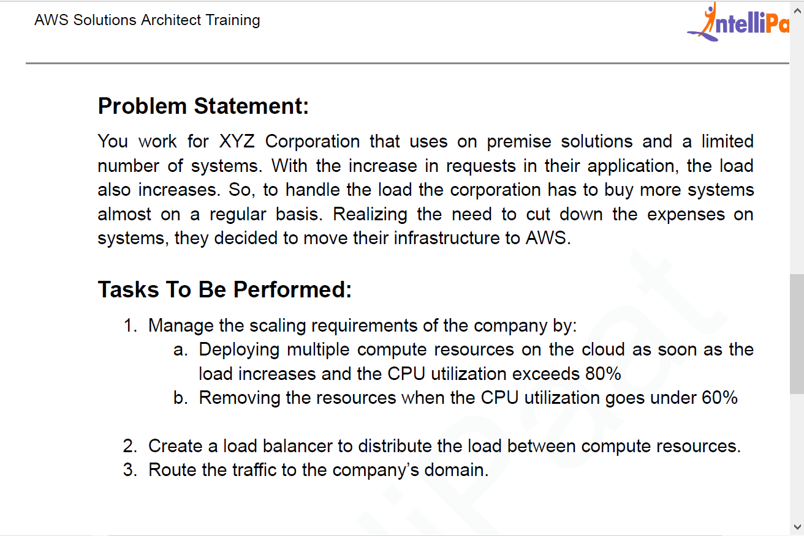

First Deploy the 3 EC2 instances with web application in 3 linux versions

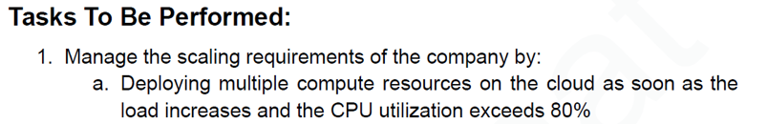

Now go to AWS Console EC2 dashboard and create 3 instances in N verginia Region

Ubuntu instance launched -1

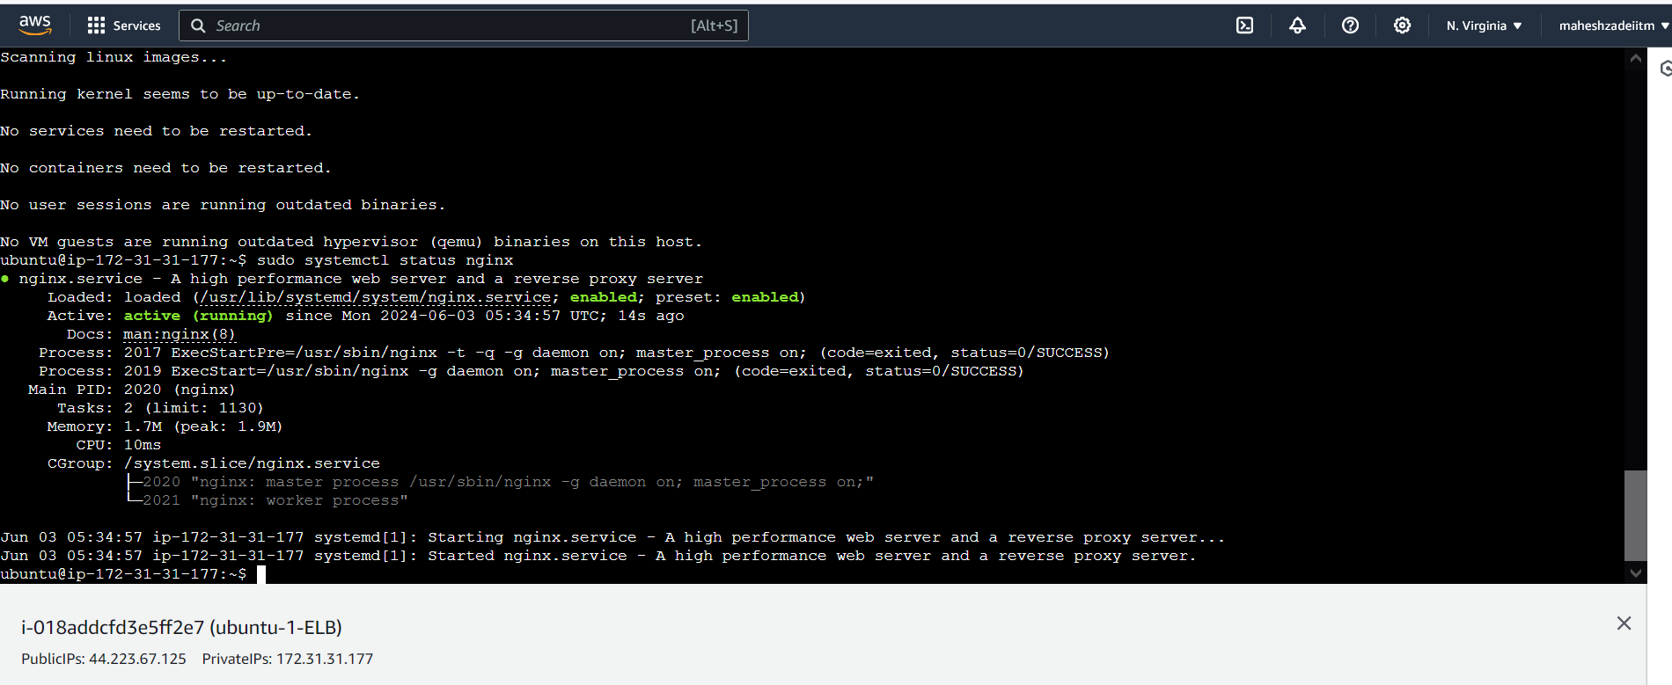

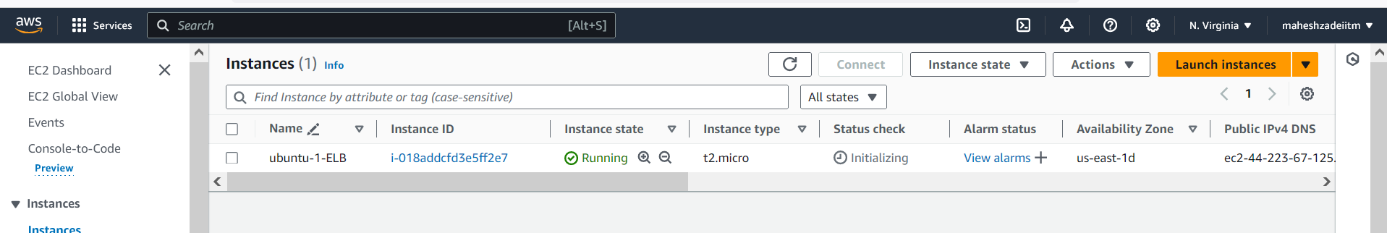

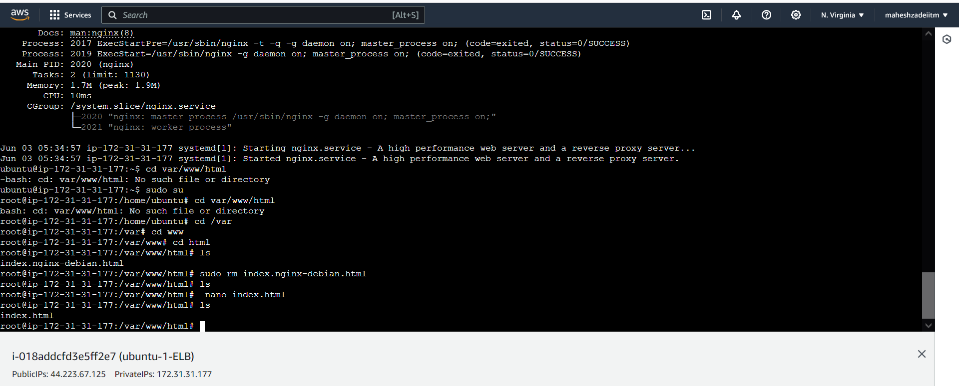

Comands used below

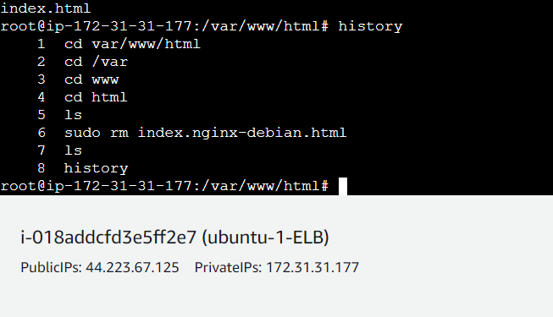

Copy the public IP and check and any browser

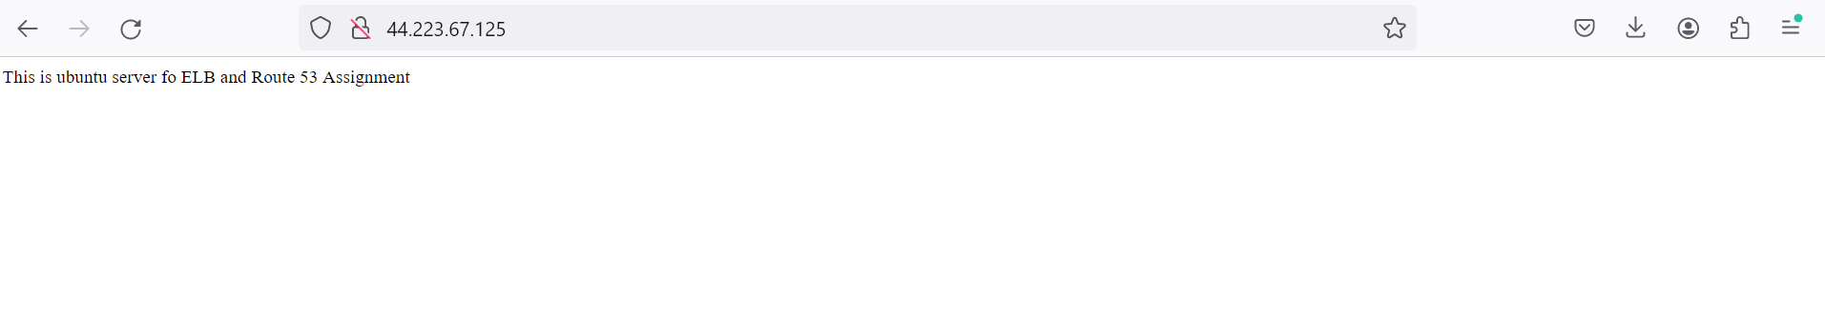

Its working now

Now Install the second linux Machine

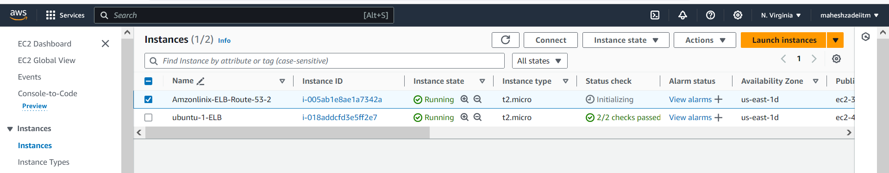

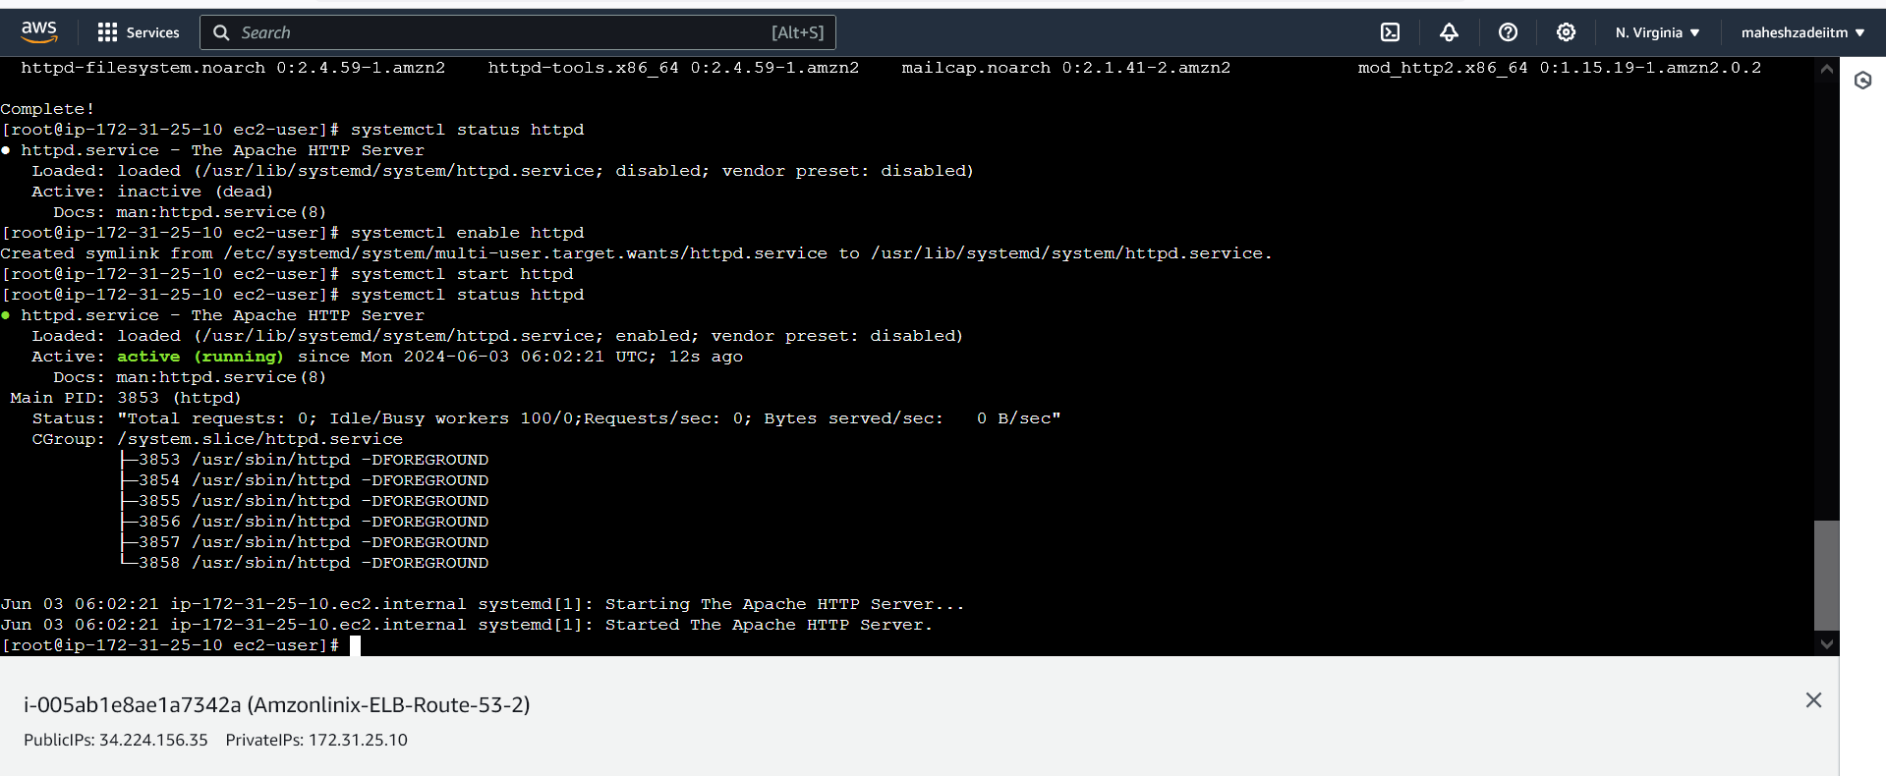

Commands run

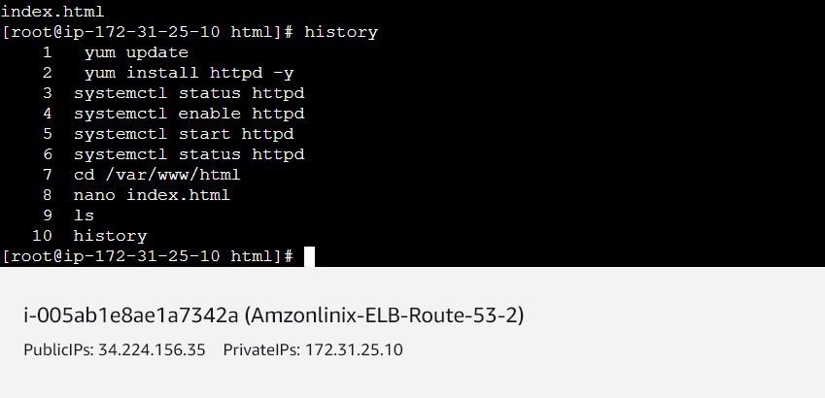

Now copy the public IP and check the website is running or not

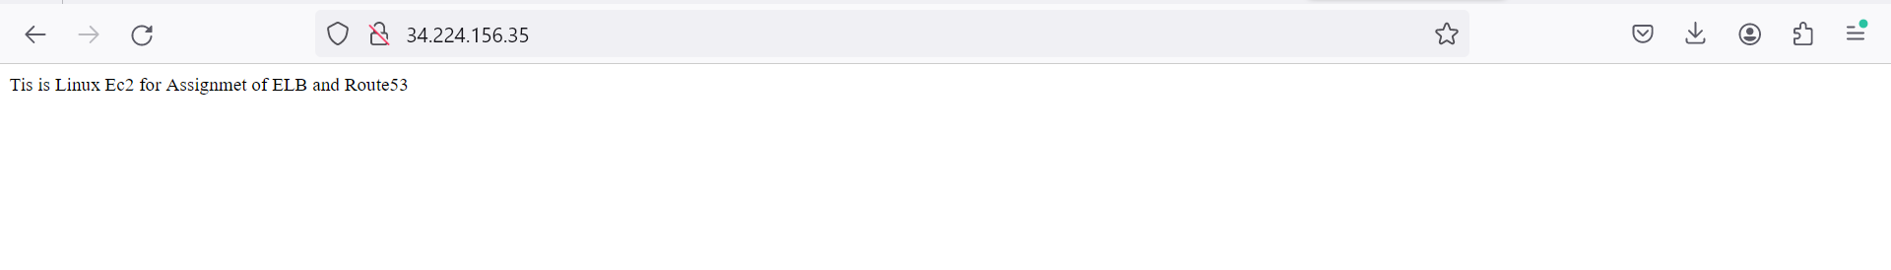

Now create the third EC2 Redhat instance

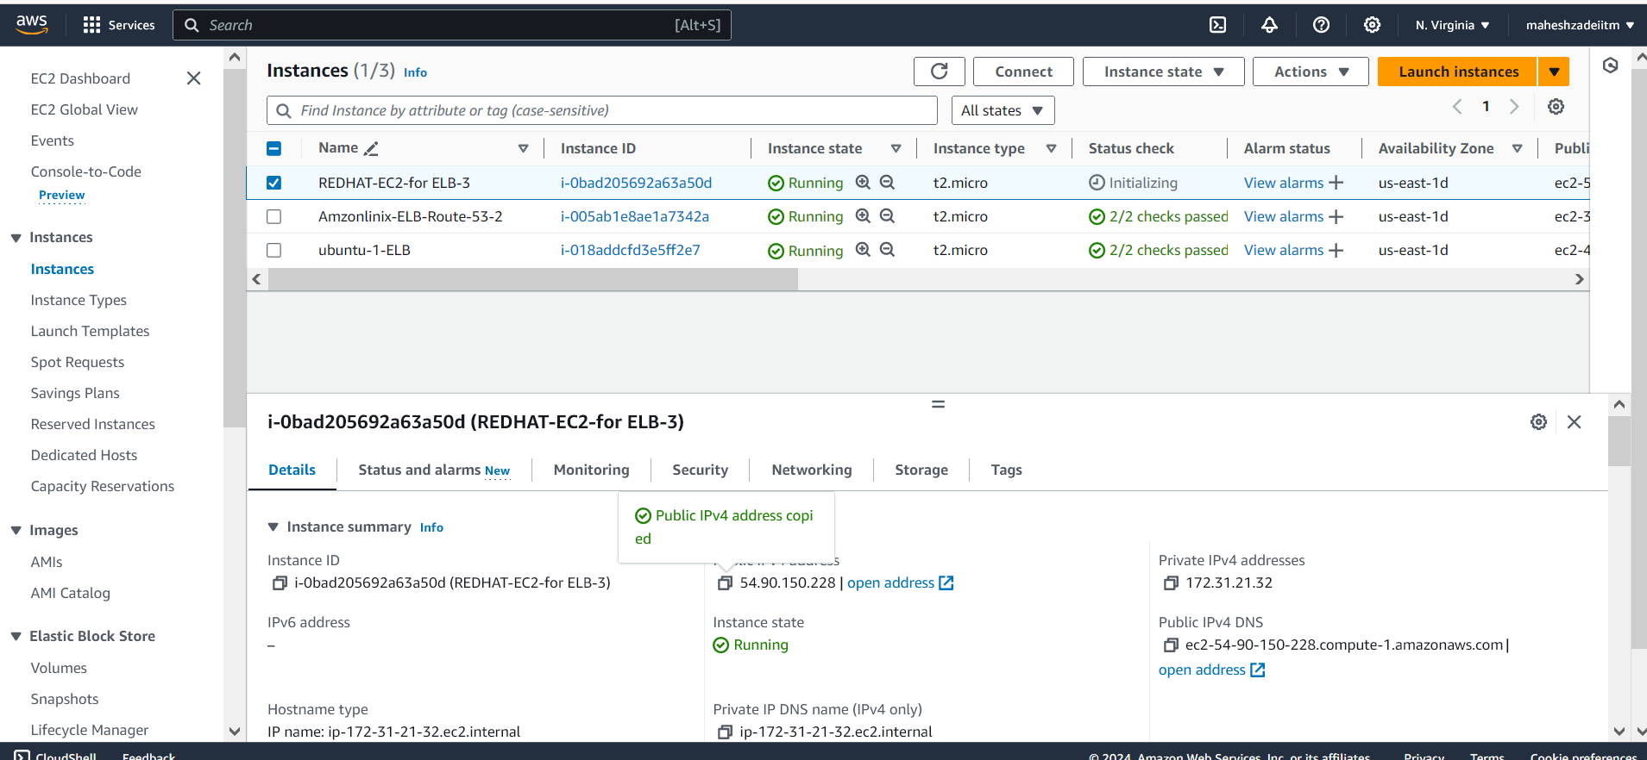

Apache server in running now and is active

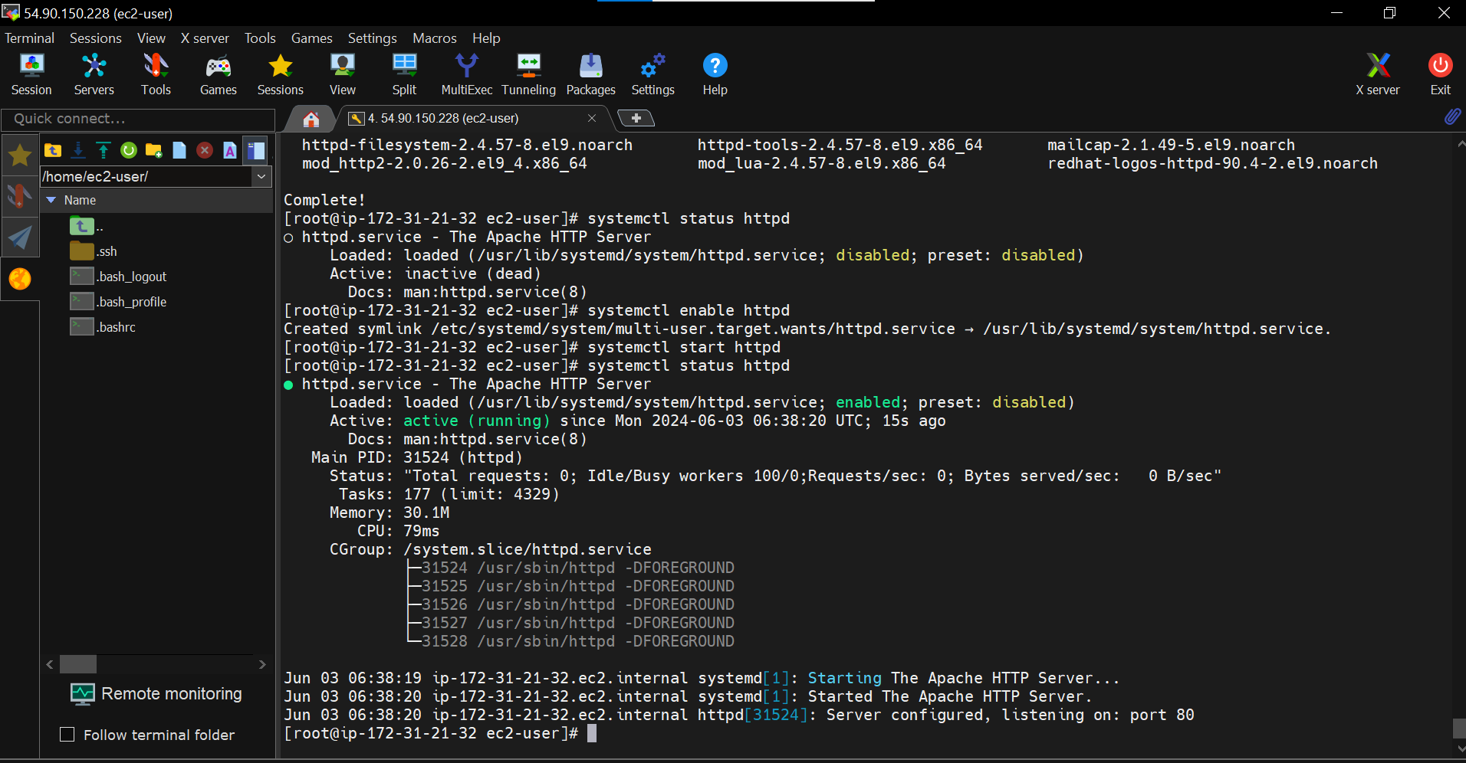

Now copy the public IP and paste in the browser

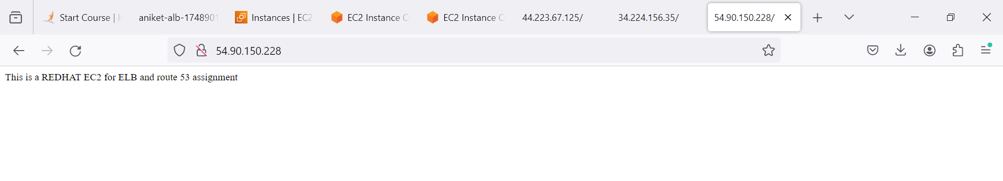

Command run in red hat machine

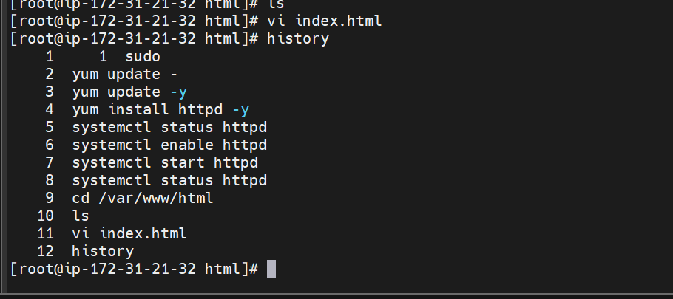

Now we have to create the Target group for health check for the Targets for load balancer .

Target group checked the health status on the registered targets to remind the health status .

After this only healthy targests going to receive the traffic.

Target could be anything Lambala Funtion , EC2 , IP address , Load balancer etc.

This the primary purpose of the Target group and load Balancer.

Go to AWS Console in target group and create the Targets in N Virginia region

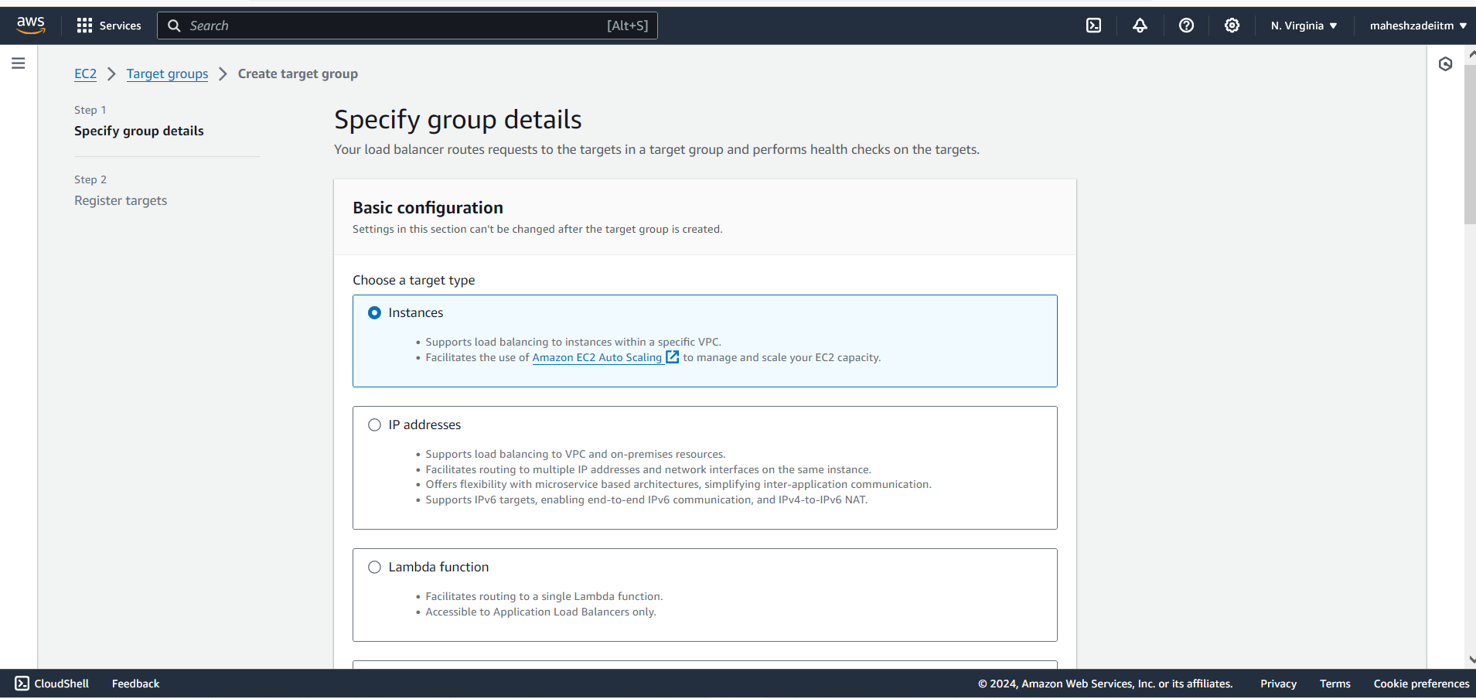

Give the Target group name

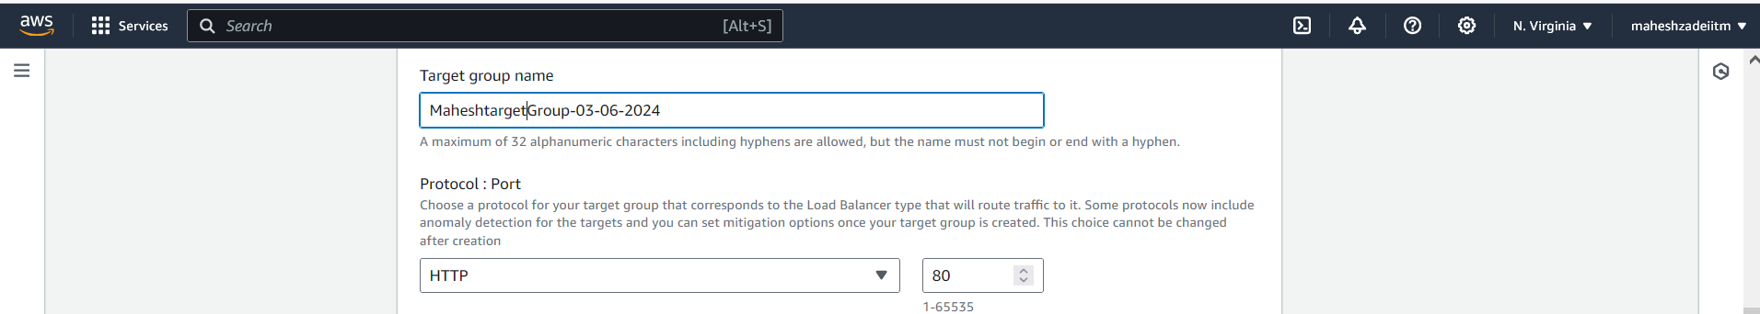

Keep the http port as 80

Keep the all the setting as it is and click on Next

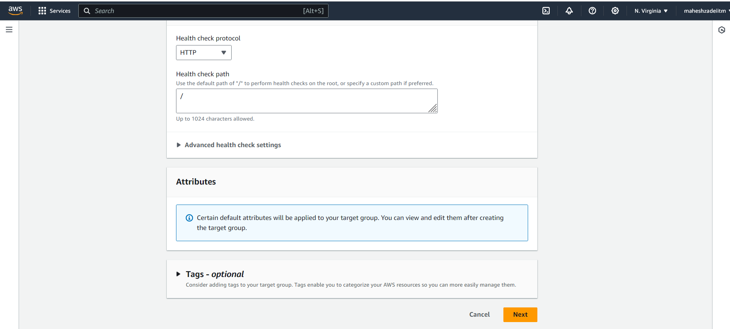

Click on registered targets

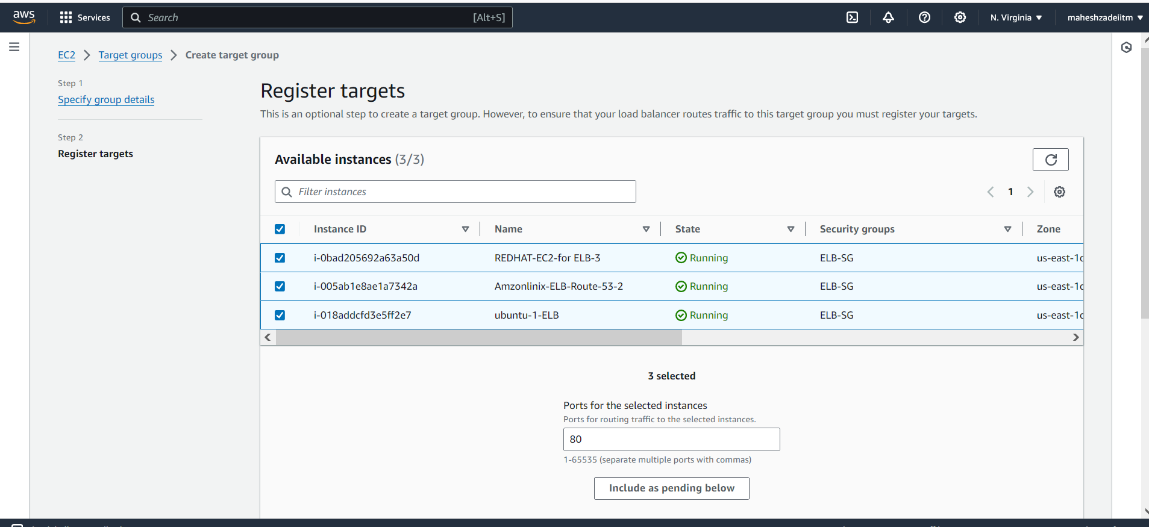

And now click on include as pending

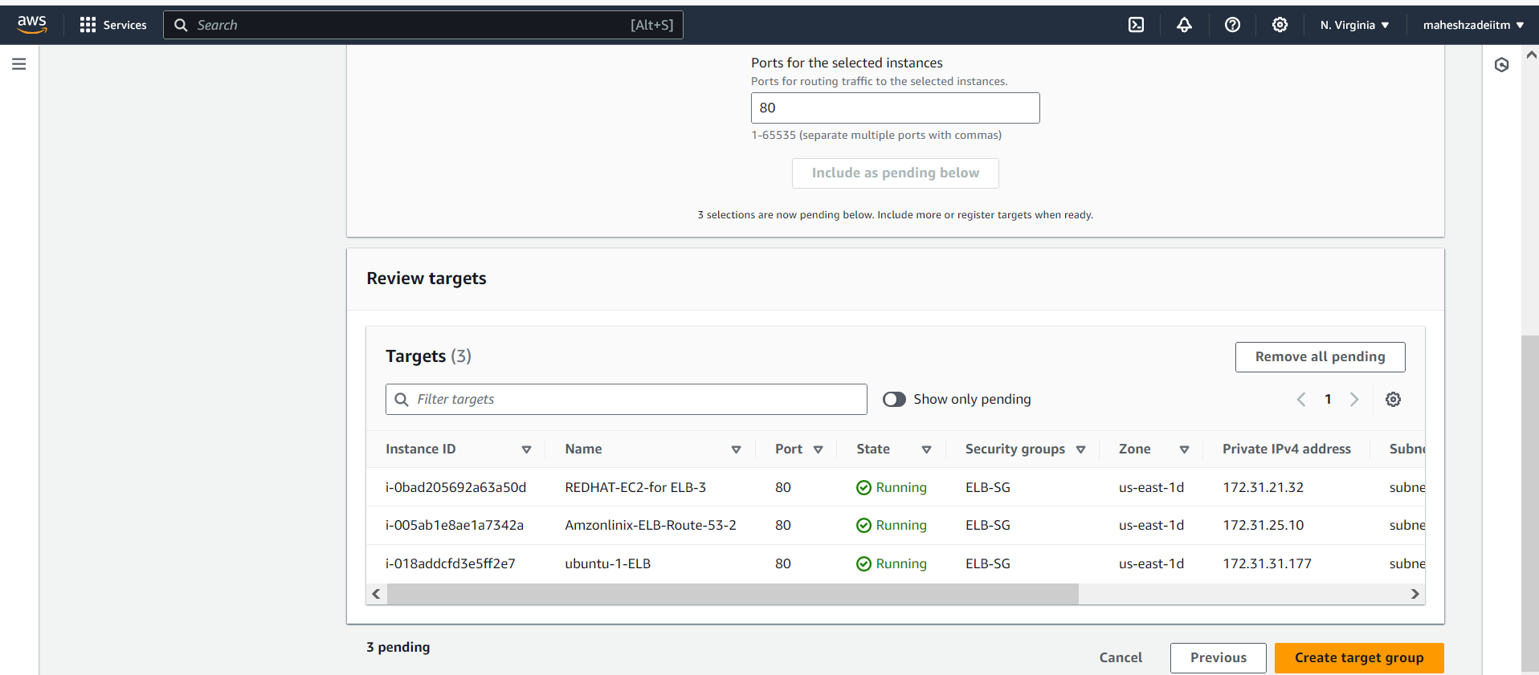

Now click on create Target group

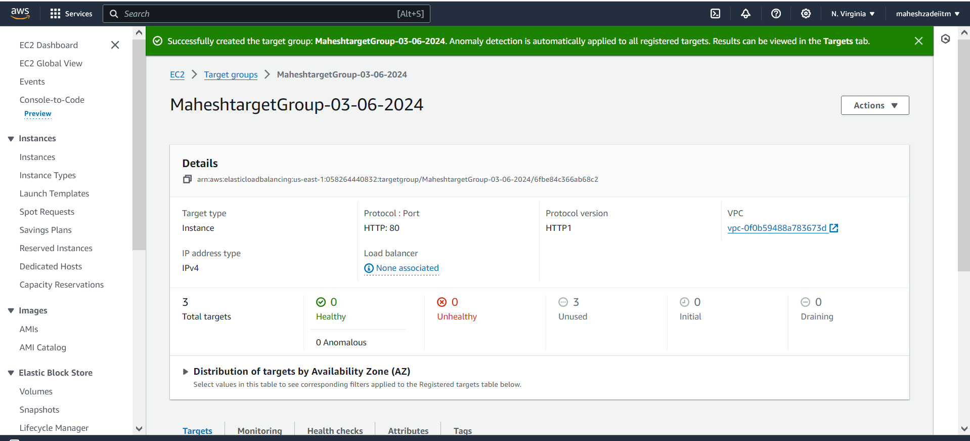

Targets are showing unused

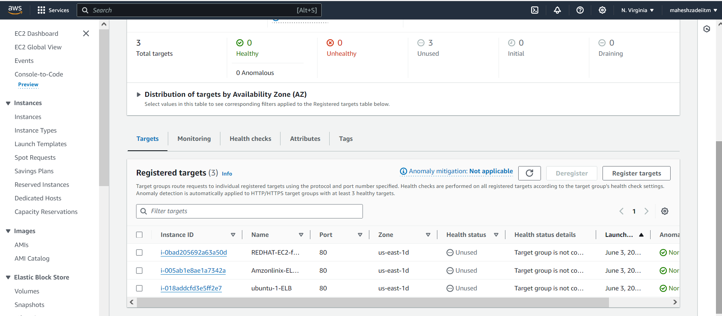

TG Created

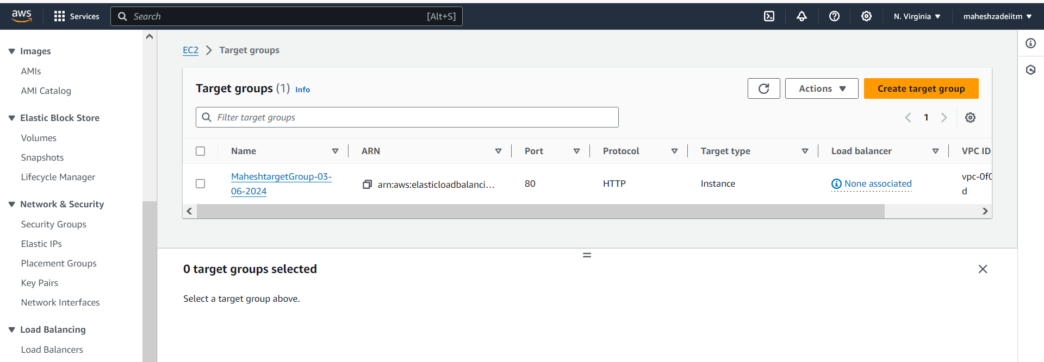

Now Go to AWS Console and Create Load Balancer ( Classic Load Balancer )

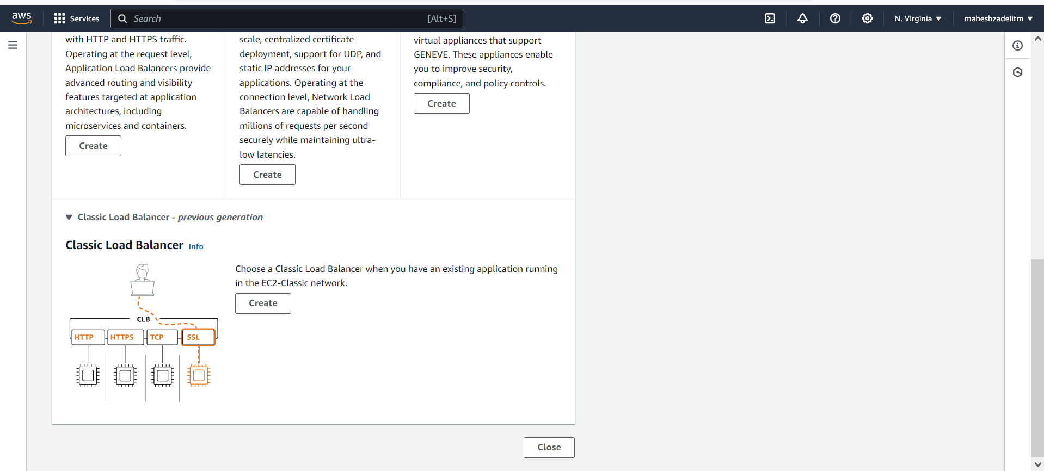

Click on create

Classic Load Balancer

The Classic Load Balancer distributes incoming application traffic across multiple EC2 instance targets in multiple Availability Zones. This increases the fault tolerance of your applications. Elastic Load Balancing detects unhealthy instances and routes traffic only to healthy instances.

Instance health is determined by periodic ping requests, called health checks, that are sent by your load balancer to all registered instances. If an instance responds, it's considered healthy, if it doesn't respond, it's deemed unhealthy, and traffic is only routed to instances that are currently healthy. Health check settings can be adjusted during or after the creation of your load balancer.

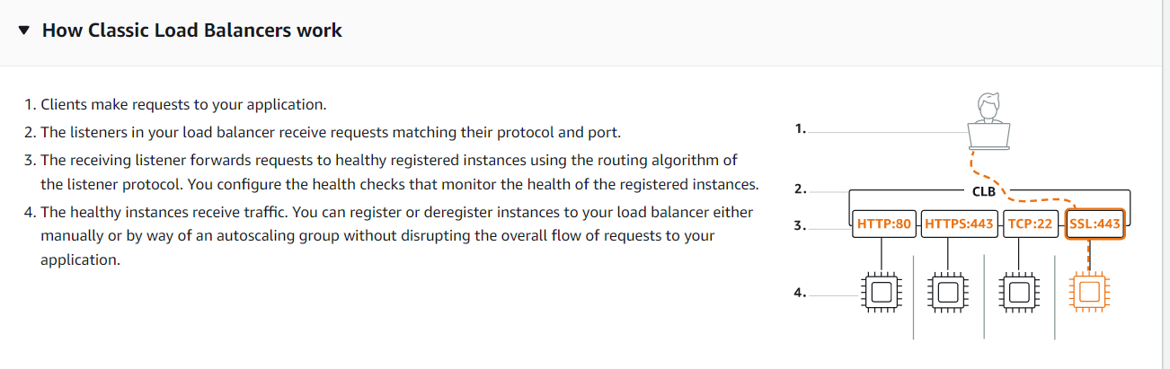

Give the Name of Load balancer

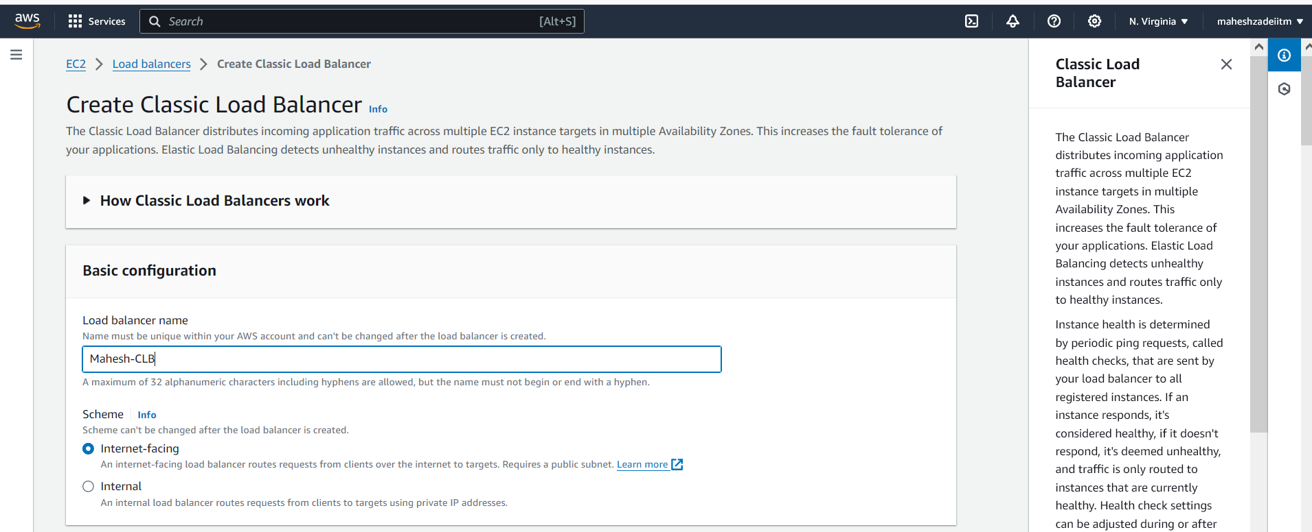

Select default VPC

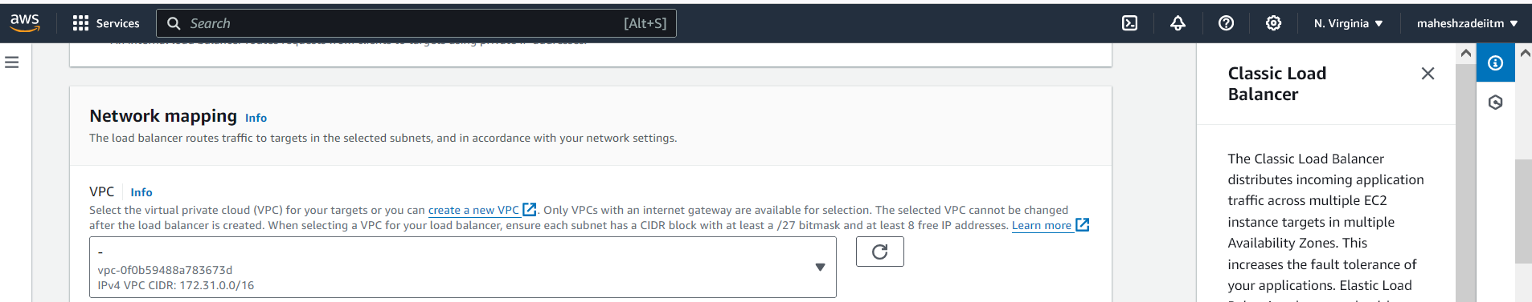

Select SG which we created

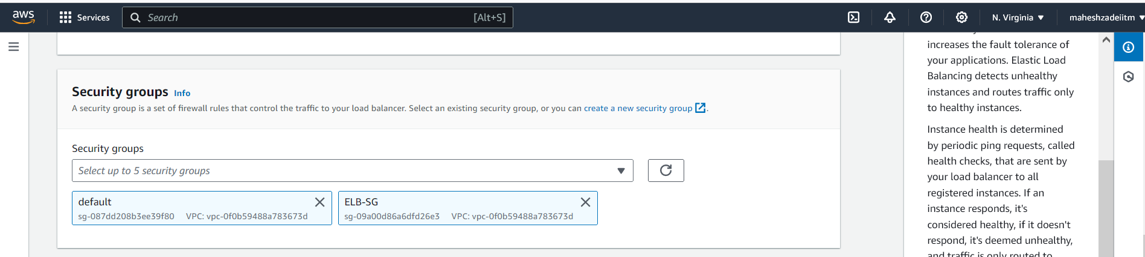

Add the instances 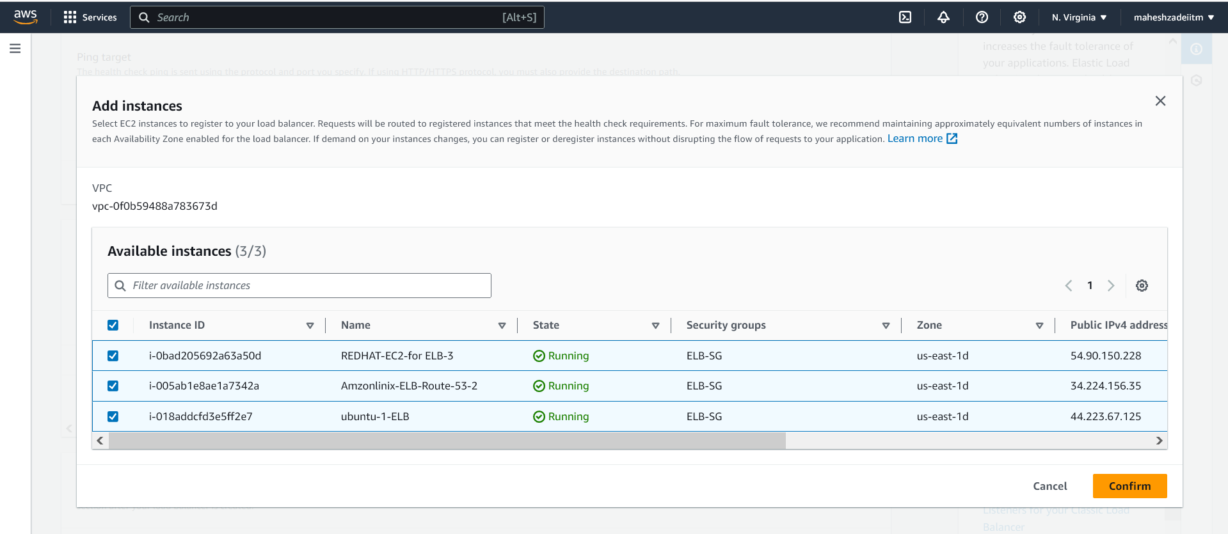

Added instances

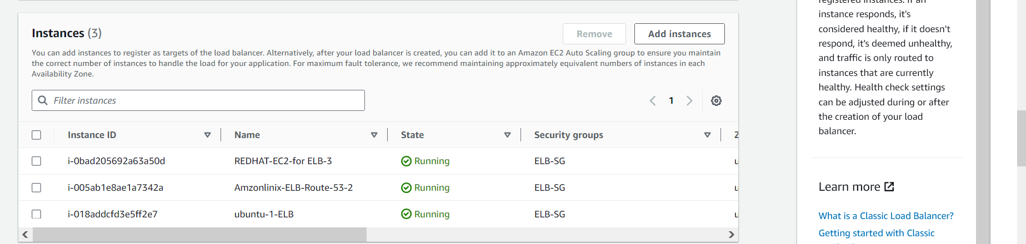

Keep the remaining setting as it is

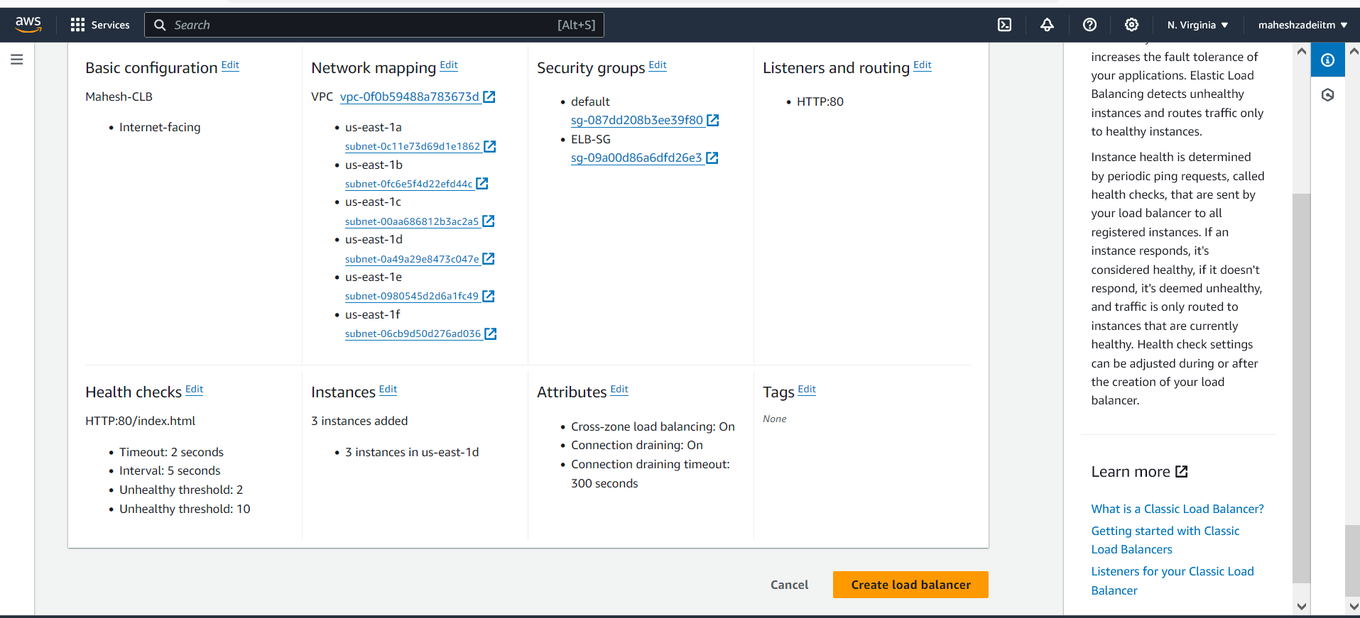

Click on Create load balancer

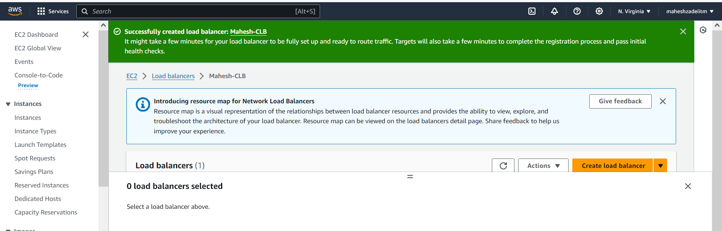

LB Created

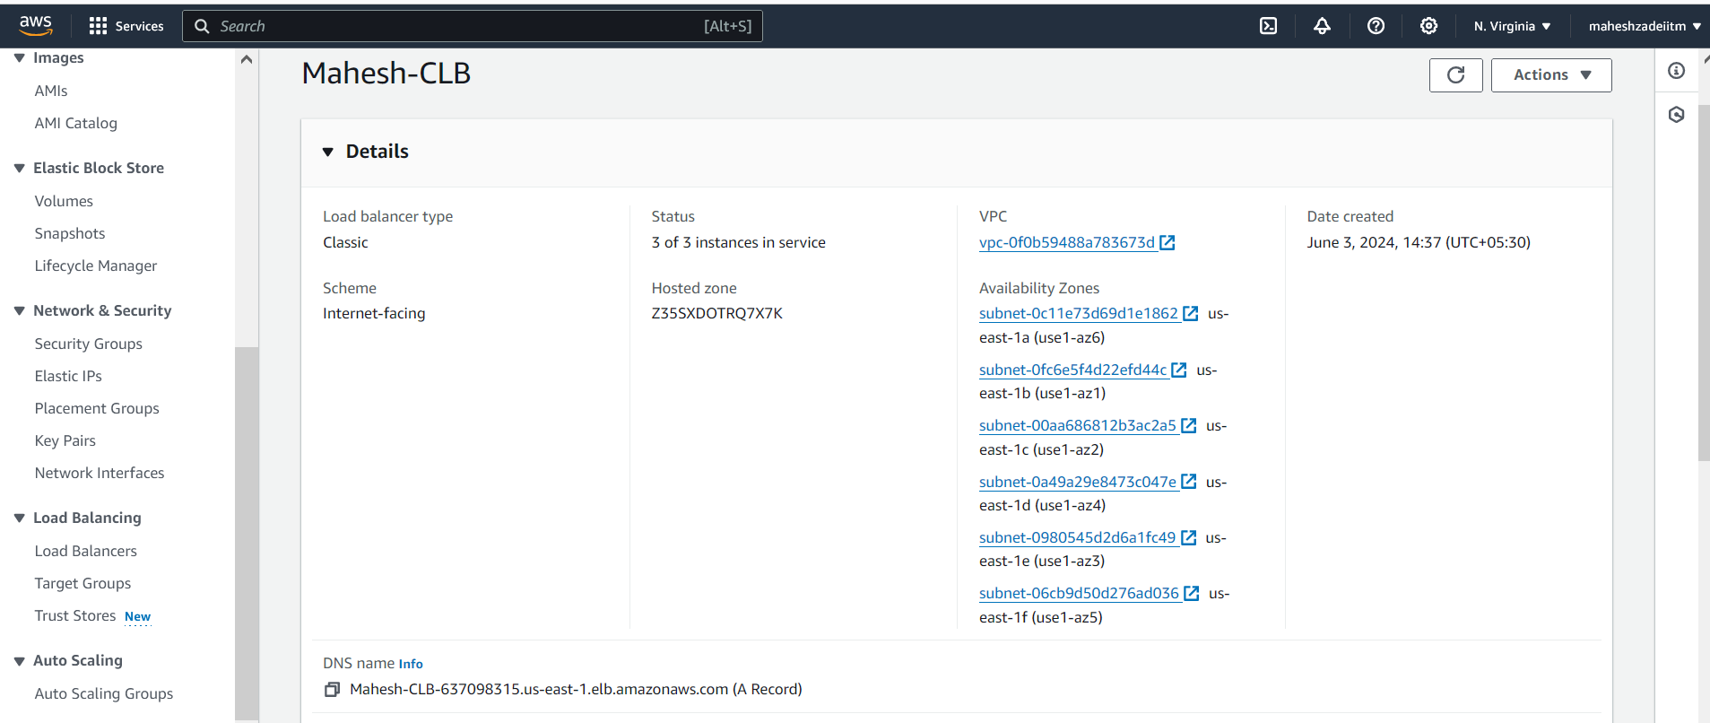

Now create the Application load Balancer

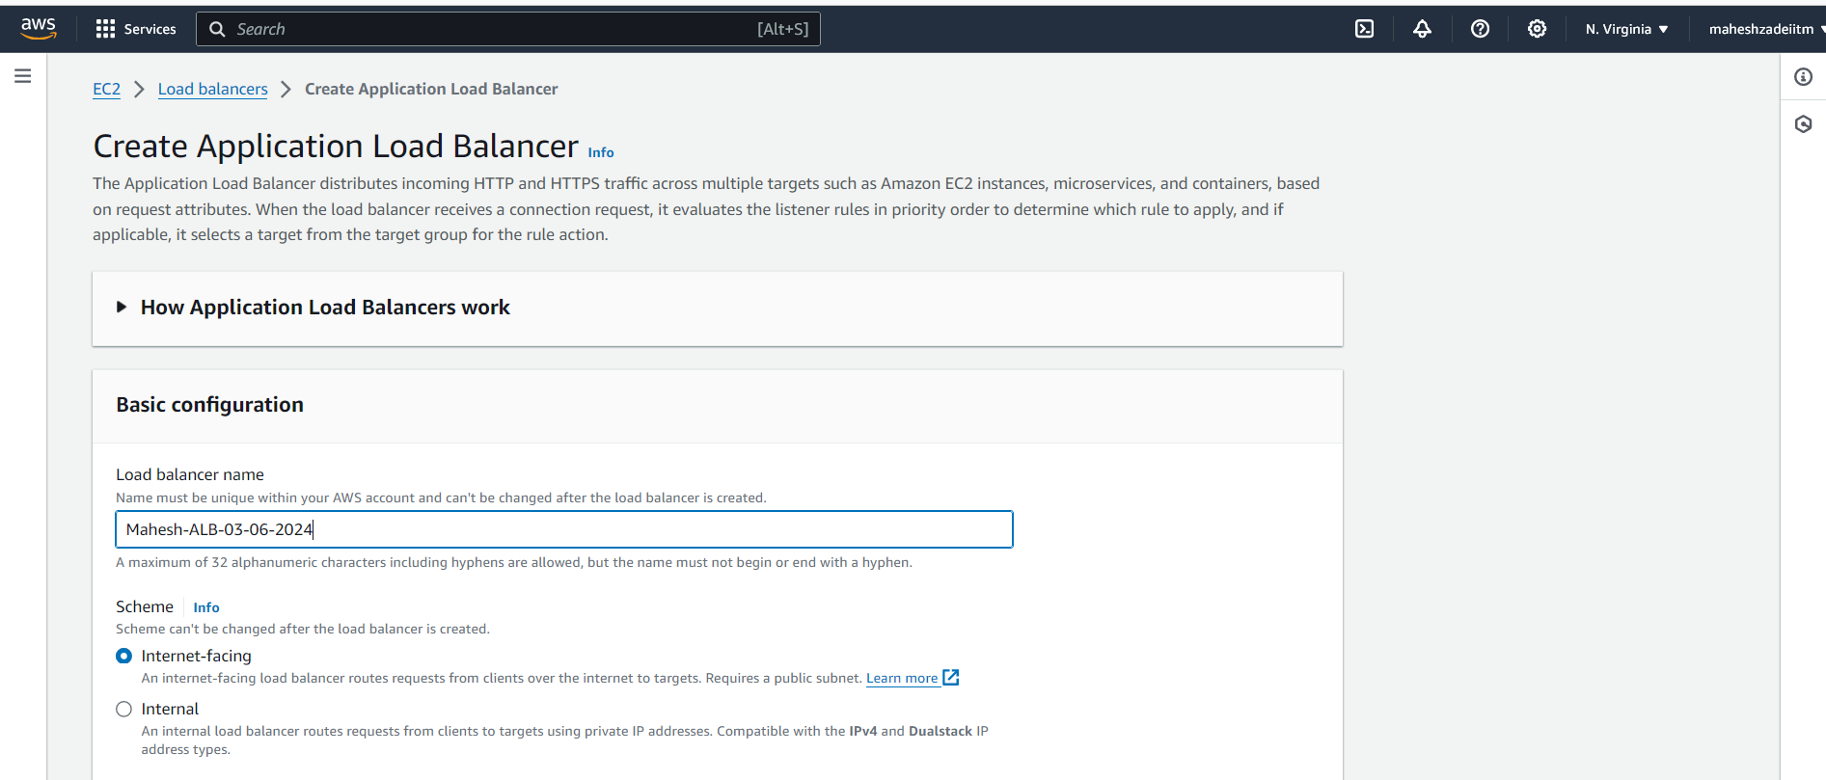

MAP all the AZ for high availability

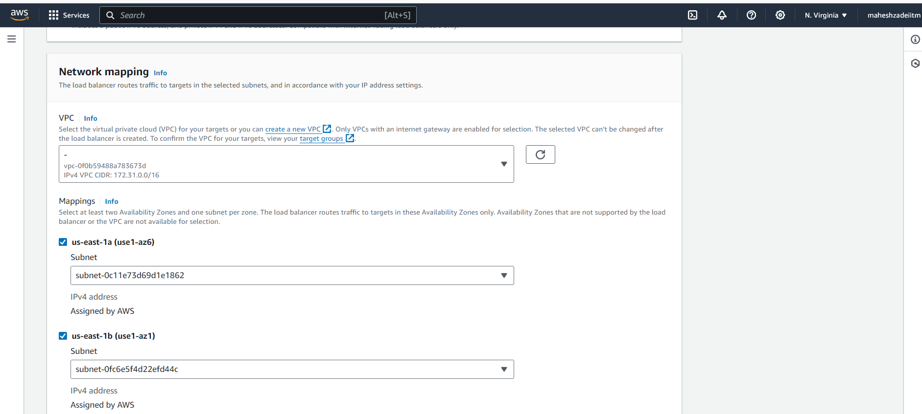

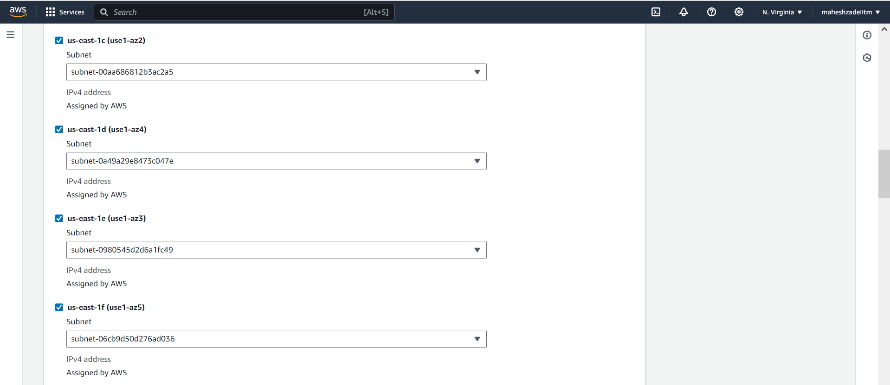

Select SG which we created.

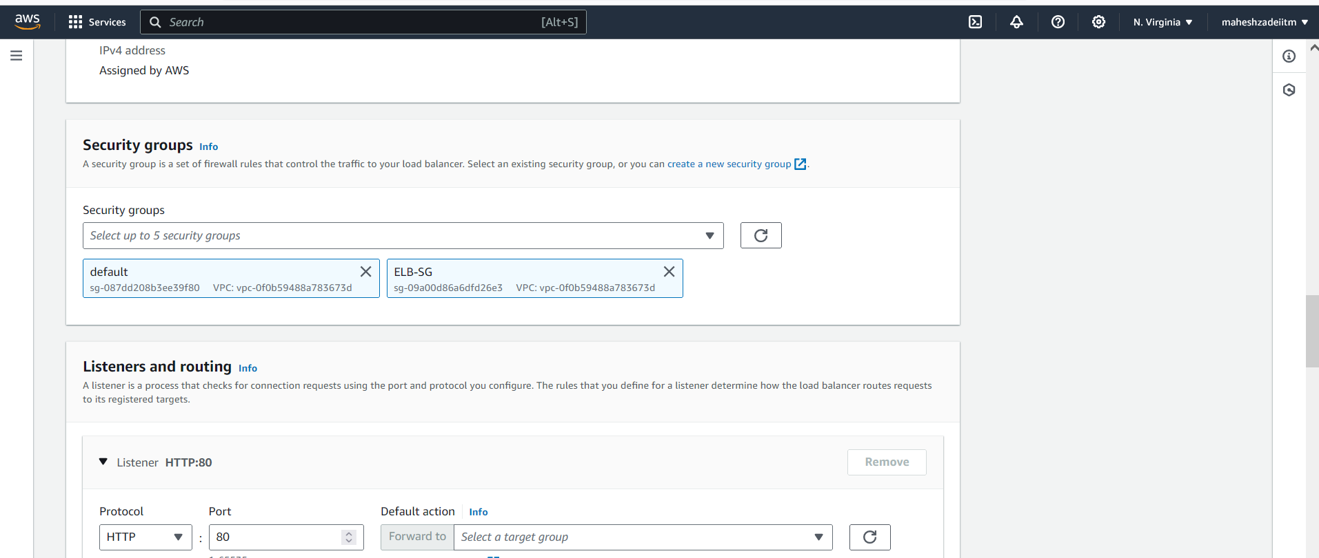

Select the TG which we created

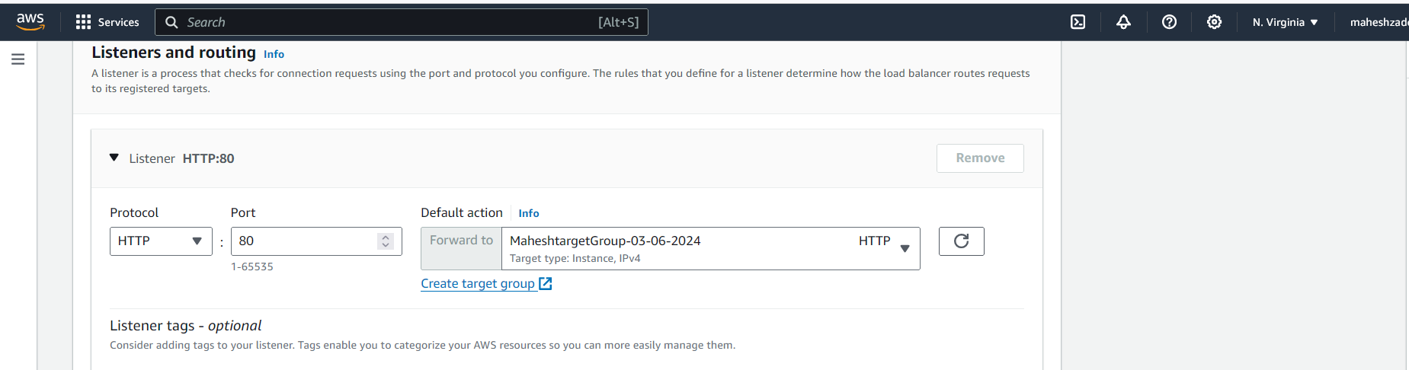

**Review the setting and click on create Load balancer**

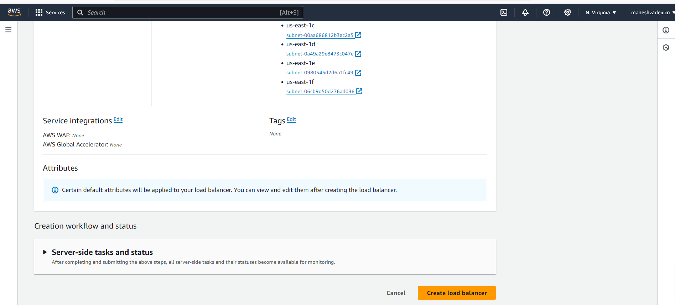

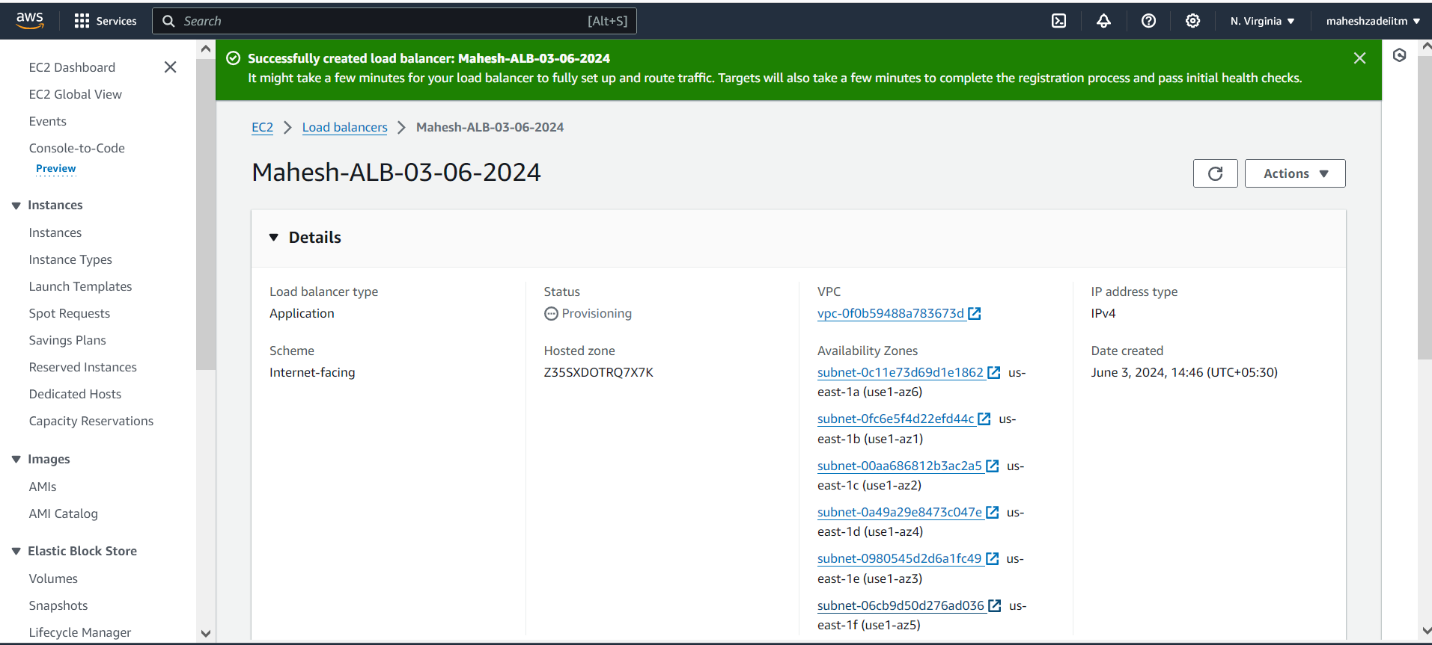

**Copy the DNS for ALB**

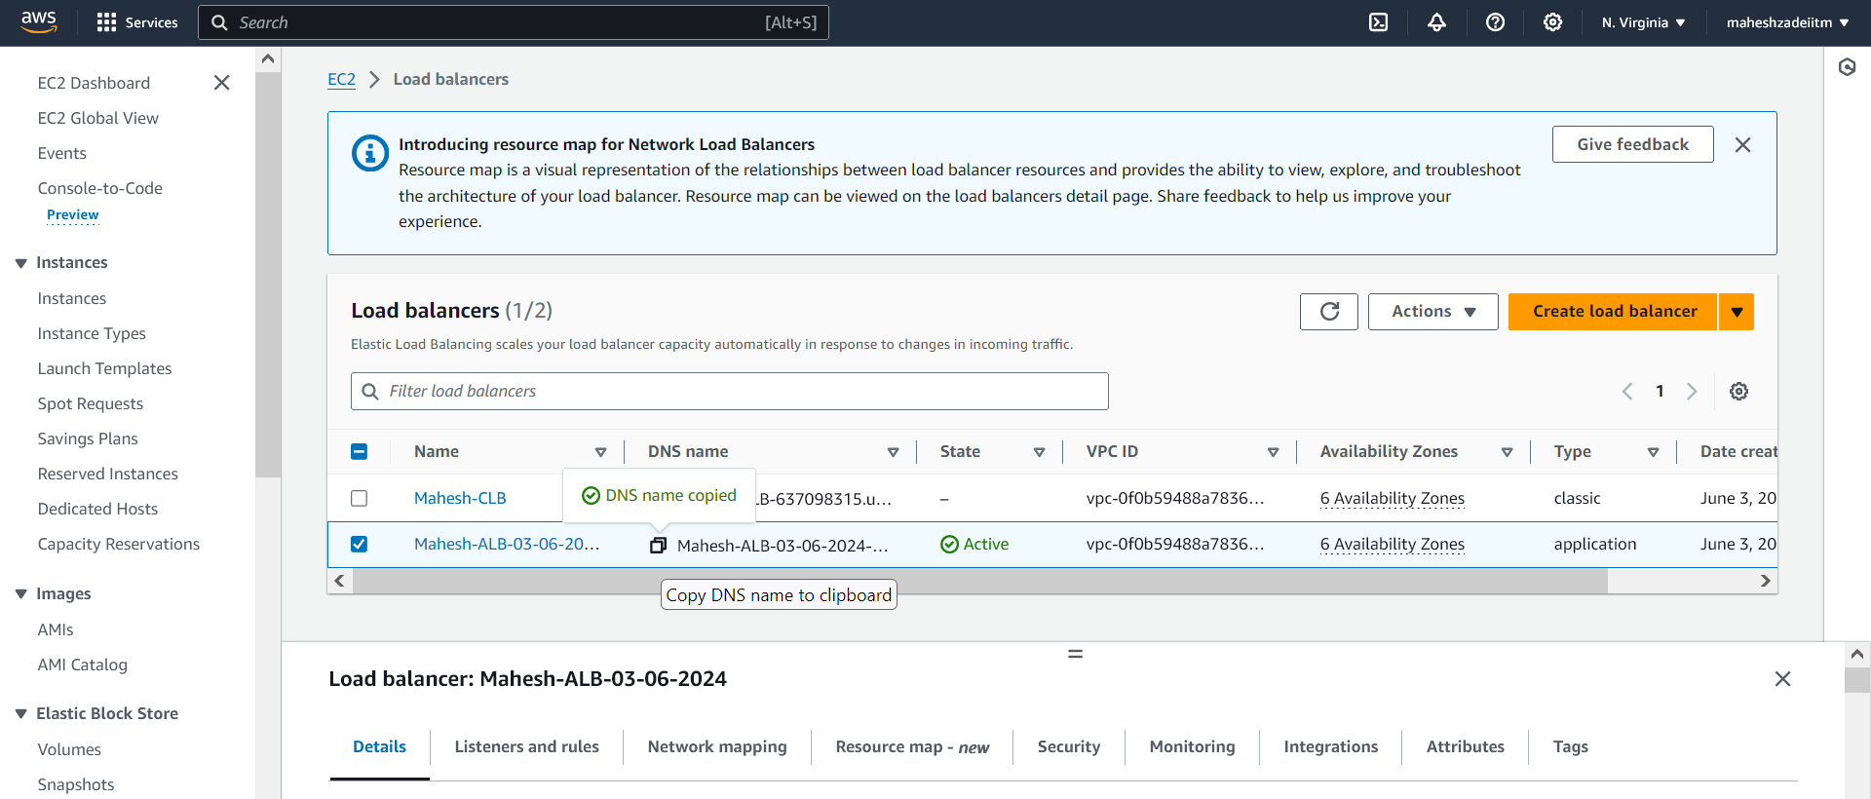

DNS of ALB

Mahesh-ALB-03-06-2024-1532921324.us-east-1.elb.amazonaws.com





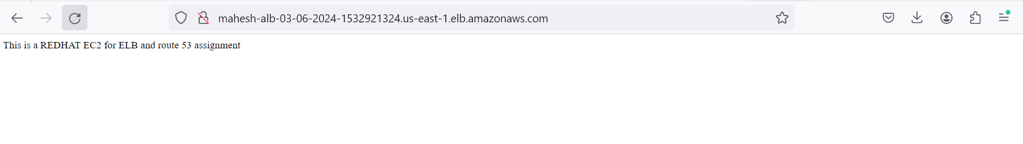

Now Classic Load Balcner is also working

DNS CLB

<http://mahesh-clb-637098315.us-east-1.elb.amazonaws.com/>

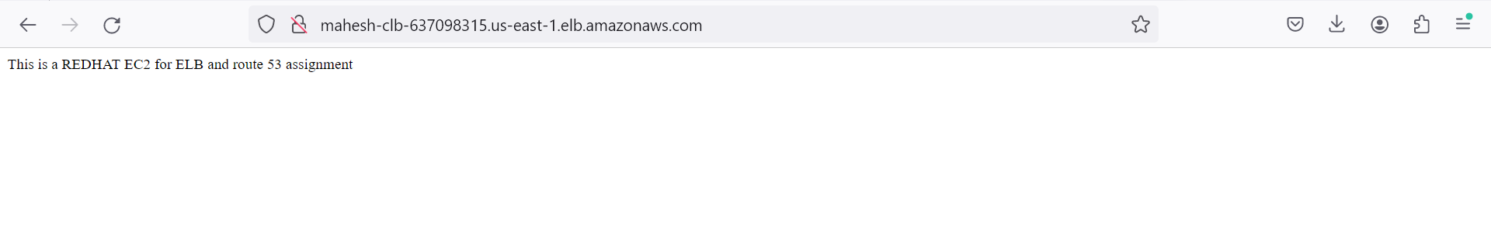



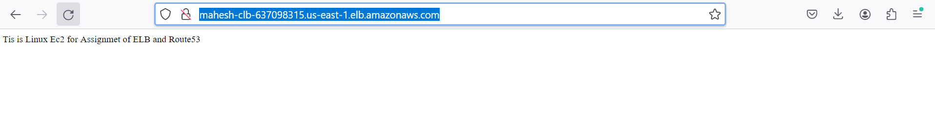

Now showing TG as Health for all the targets

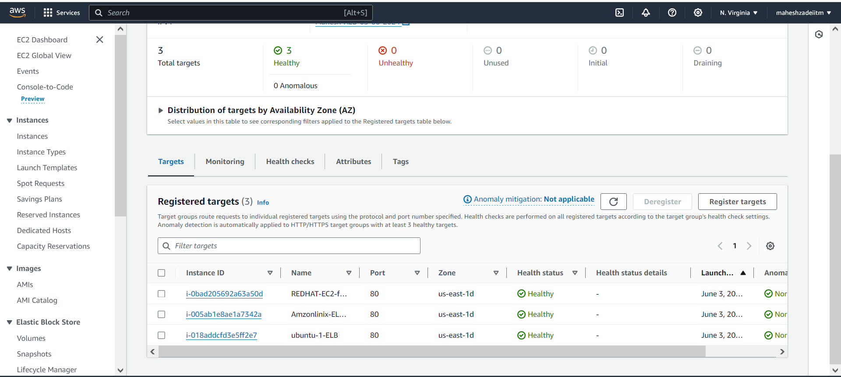

Migration of classic Load Balancer

We can do now

Go to Classic Load Balancer and go down

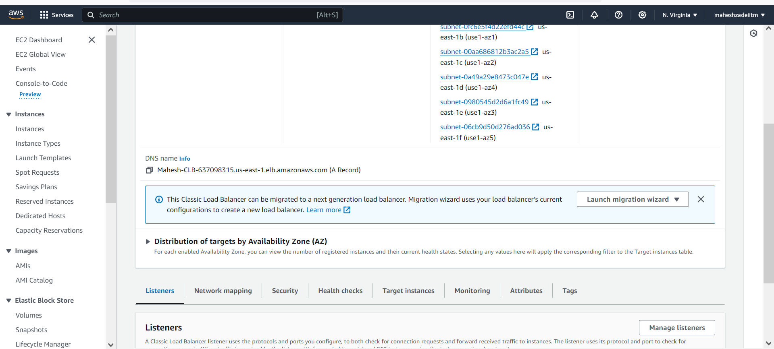

Click on Migrate to application Load Balancer

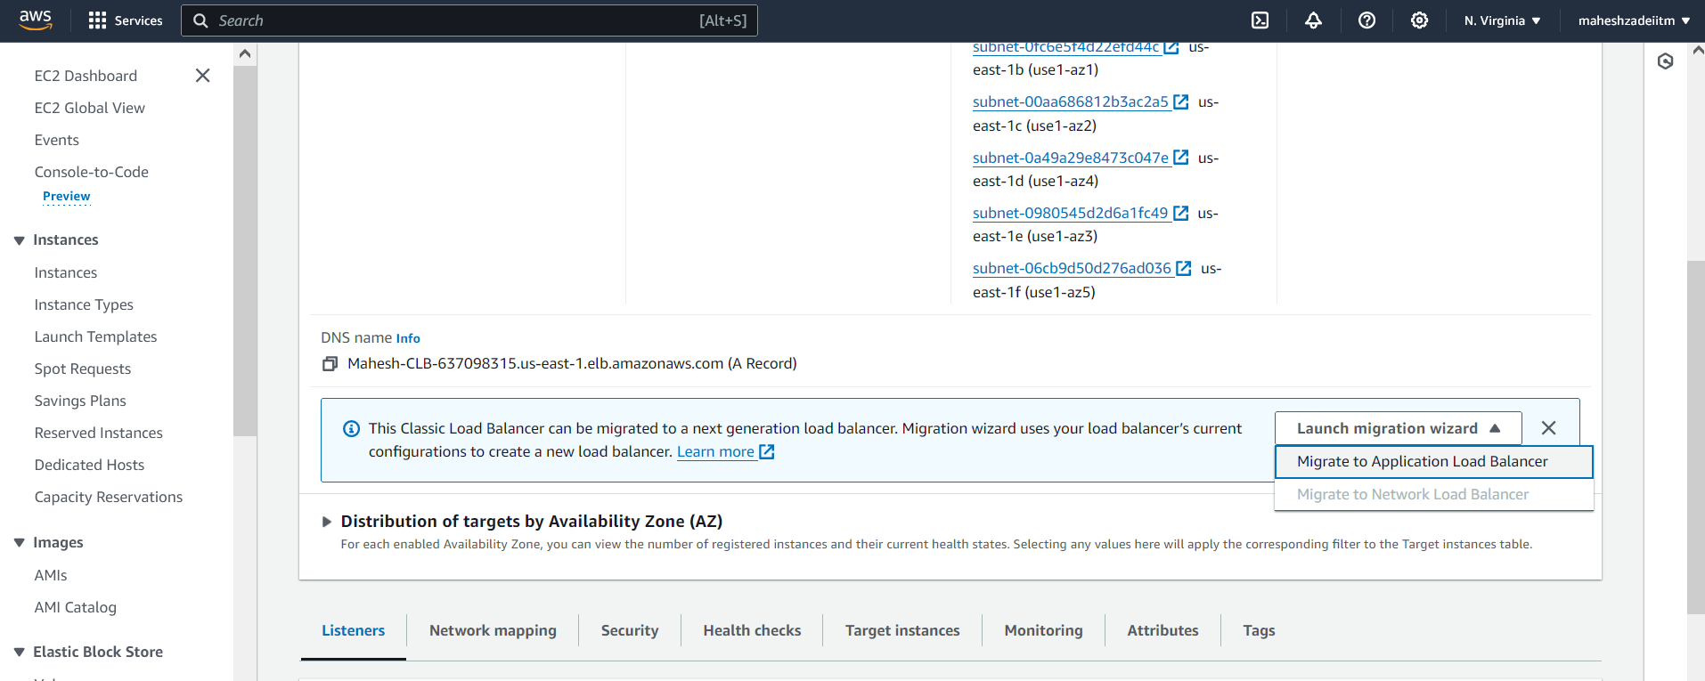

Give the name

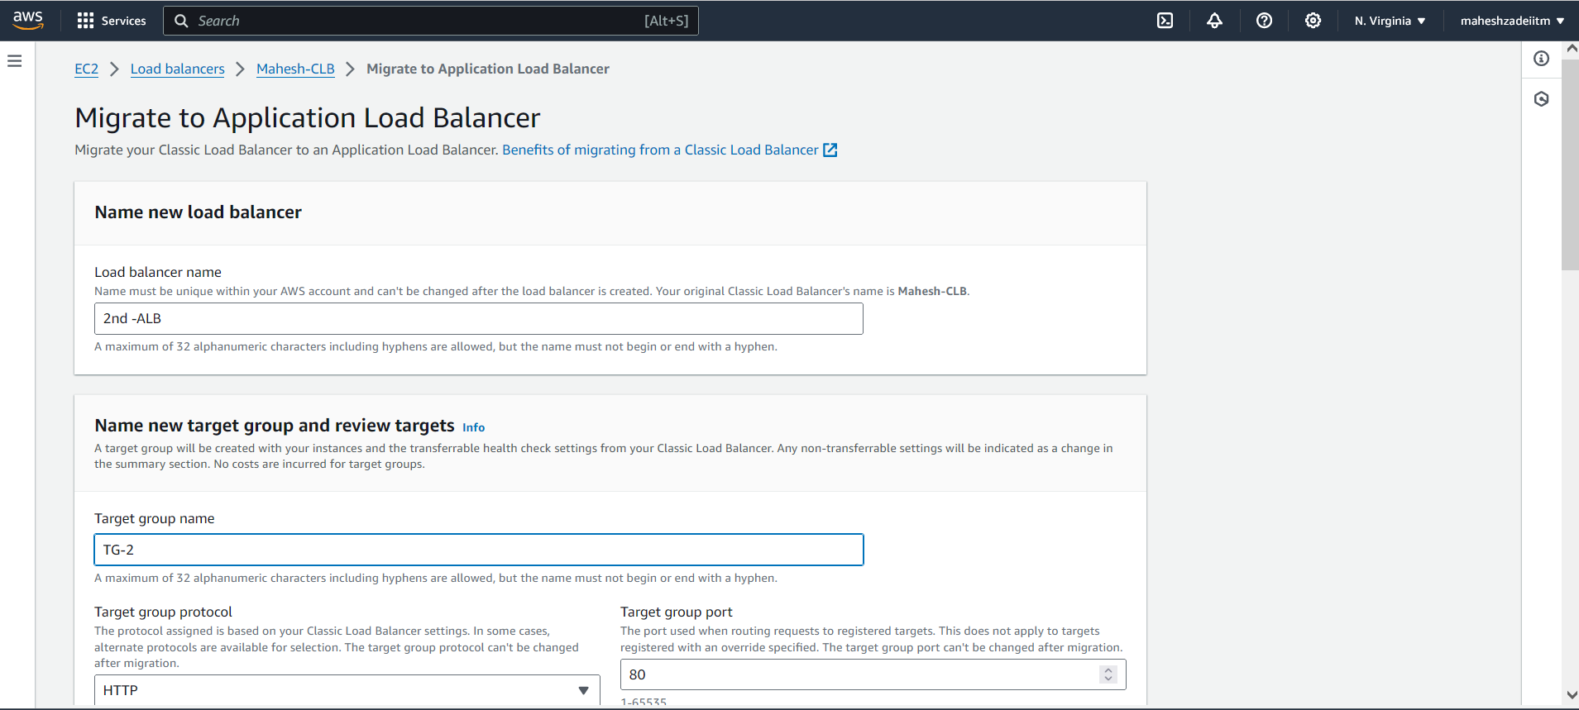

Click on application Load Balancer

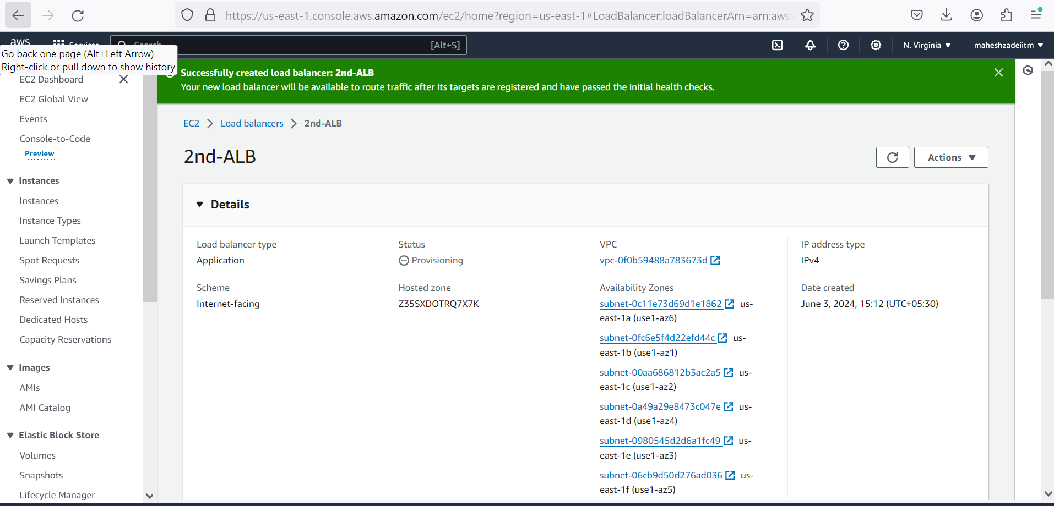

Successfully created load balancer: **2nd-ALB**

**Its showing Classic Load to Application Load Balancer**

**How Application Load Balancers work**

1. Clients make requests to your application.
2. The listeners in your load balancer receive requests matching the protocol and port that you configure.
3. The receiving listener evaluates the incoming request against the rules you specify, and if applicable, routes the request to the appropriate target group. You can use an HTTPS listener to offload the work of TLS encryption and decryption to your load balancer.
4. Healthy targets in one or more target groups receive traffic based on the load balancing algorithm, and the routing rules you specify in the listener.

2nd Load balcer DNS check

DNS URL : 2nd-ALB-820314387.us-east-1.elb.amazonaws.com

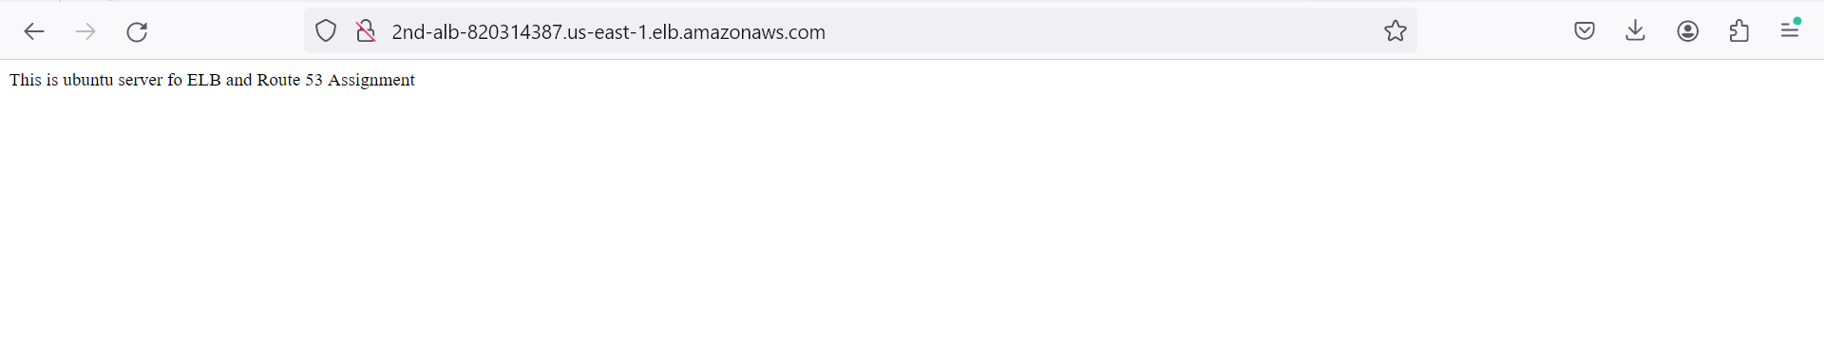



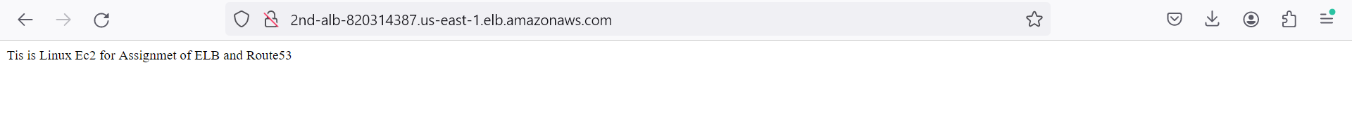

Delete the Classic Load Balancer as we Migrate it to application Load Balancer as its Assignment topic taught by Aniket Sir on dated 02-06-2024

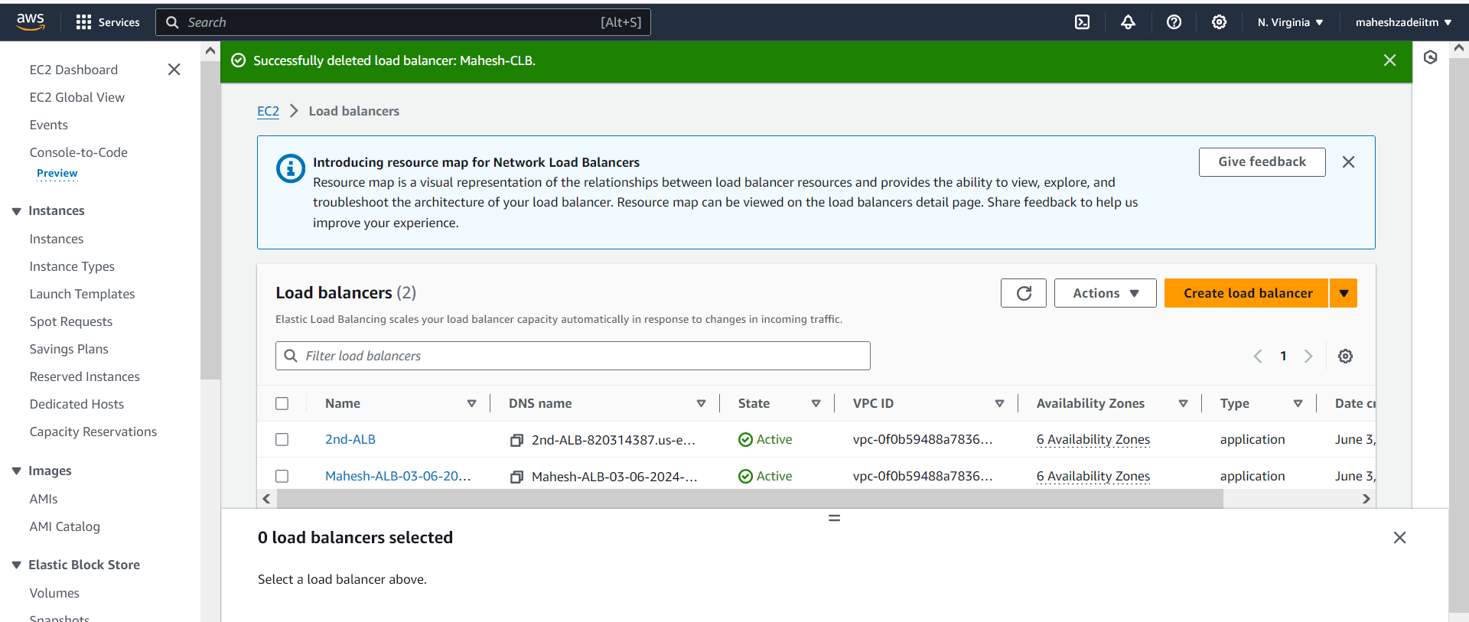

Now Go to Auto scaling in AWS Console



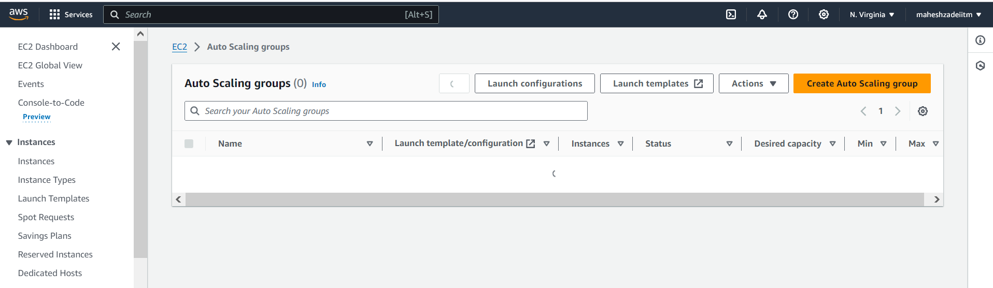

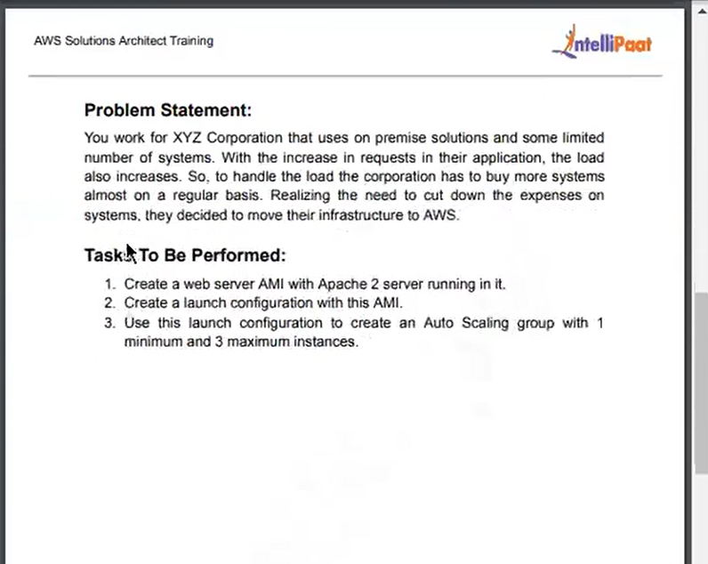

**Steps to Follow**

**EC2-AMI-Launch Template -Configure Autoscaling Group-max 3 instances**



All Ec2 Instances created as web servers

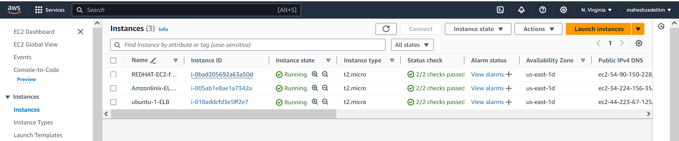

Now Create the AMI using Ec2 instances

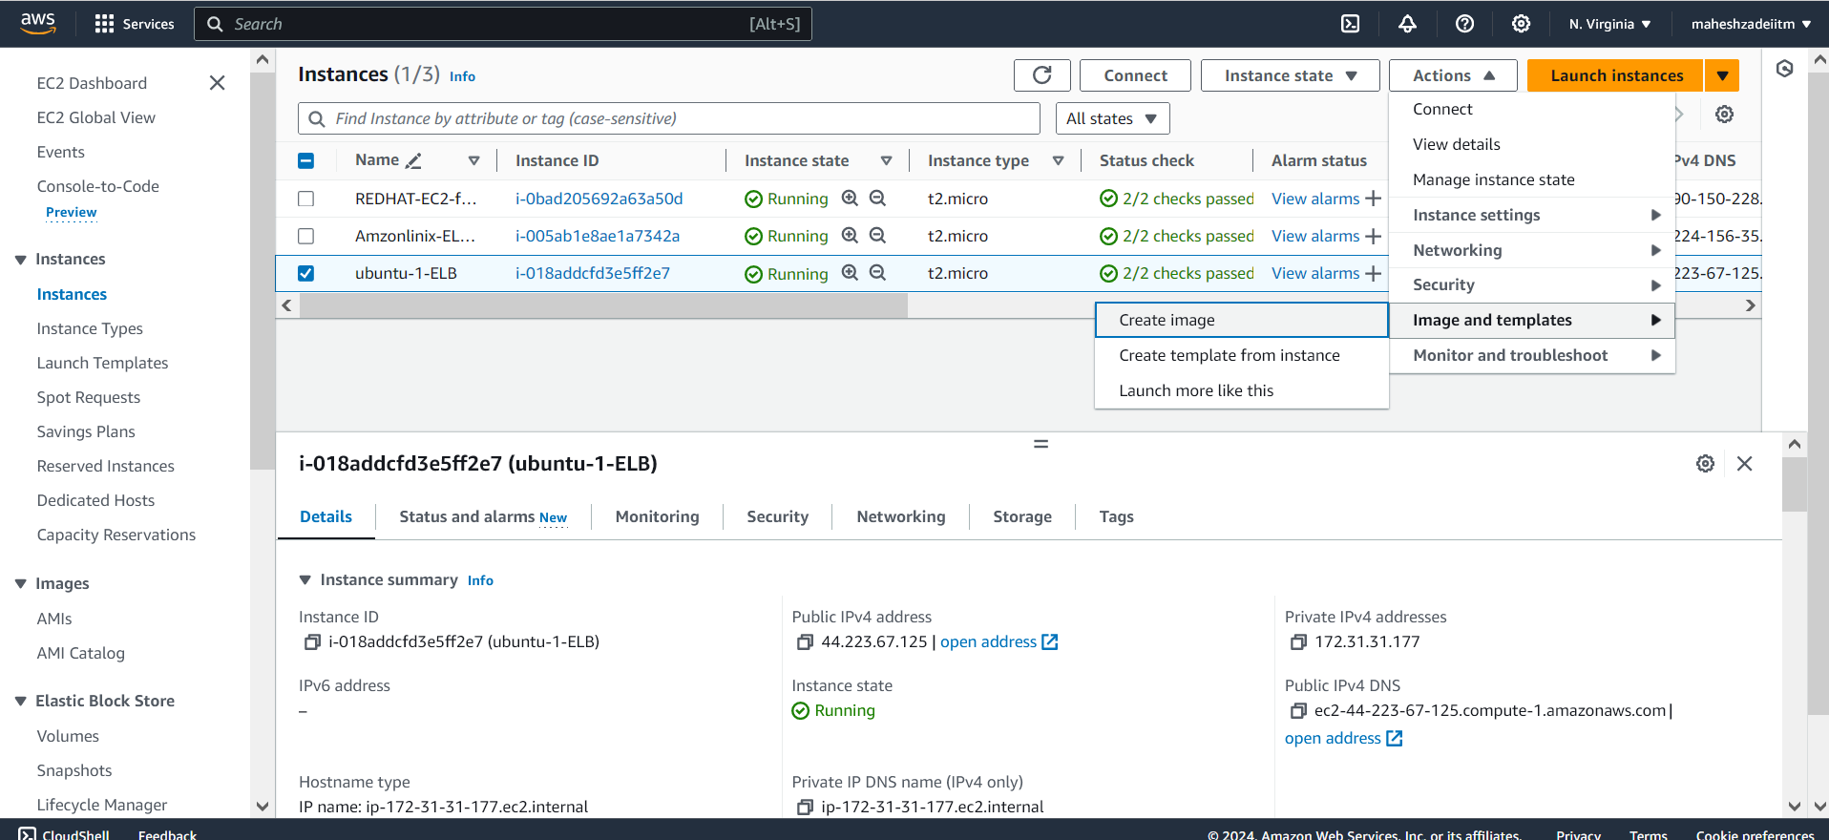

Give the name demo-image

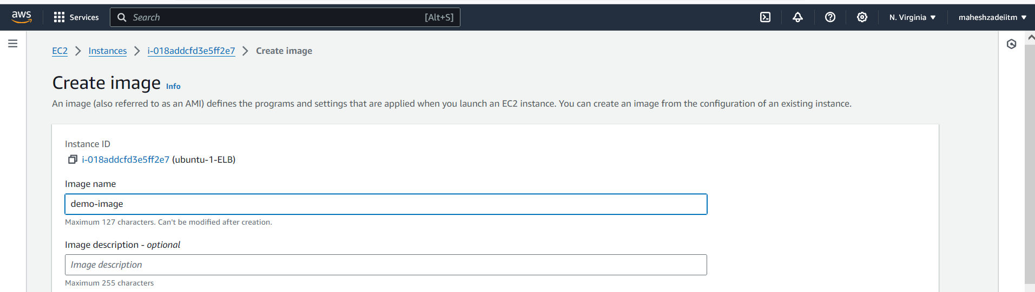

Create Image

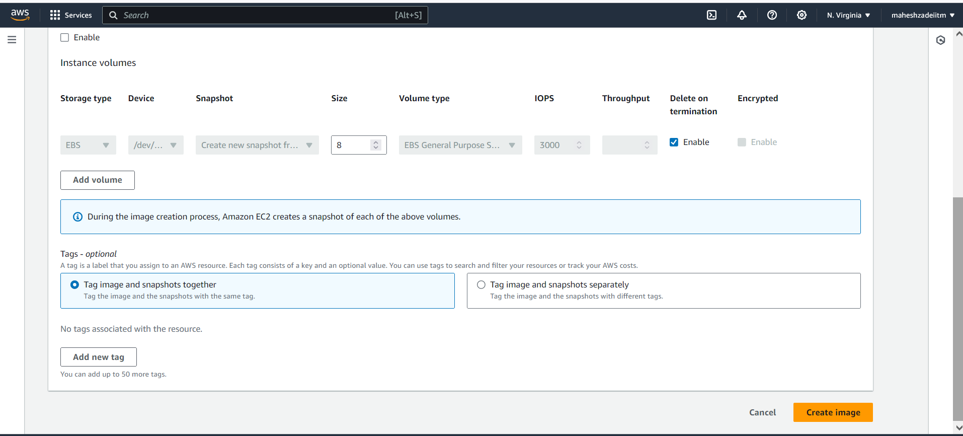

Image Created

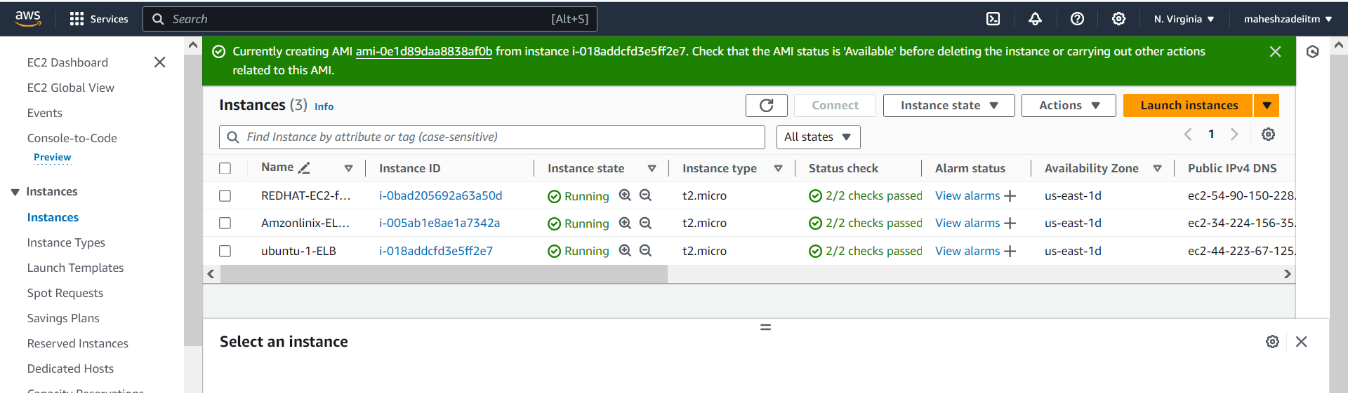

AMI Created

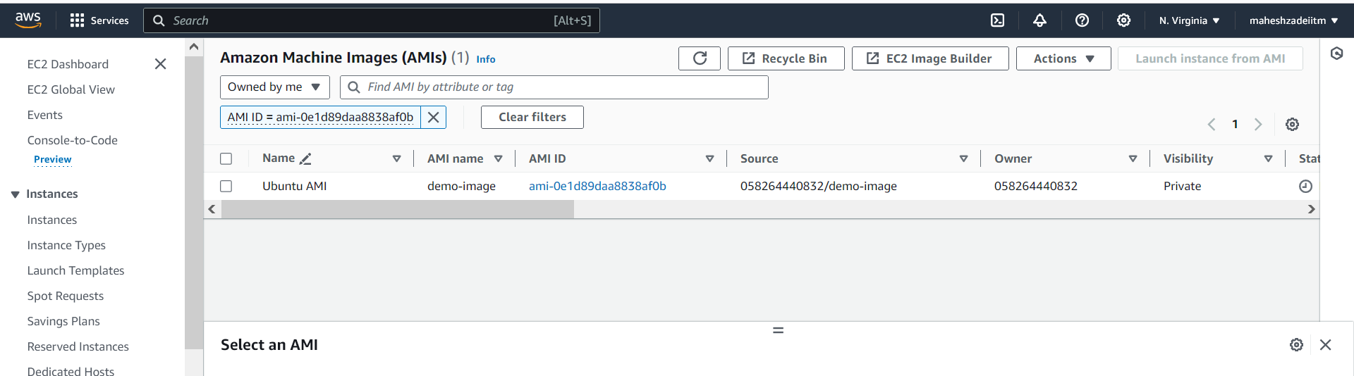

Wait till status is available

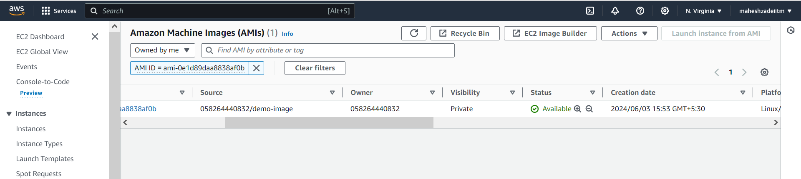

Now go to AWS Console to Launch Template and give the Name

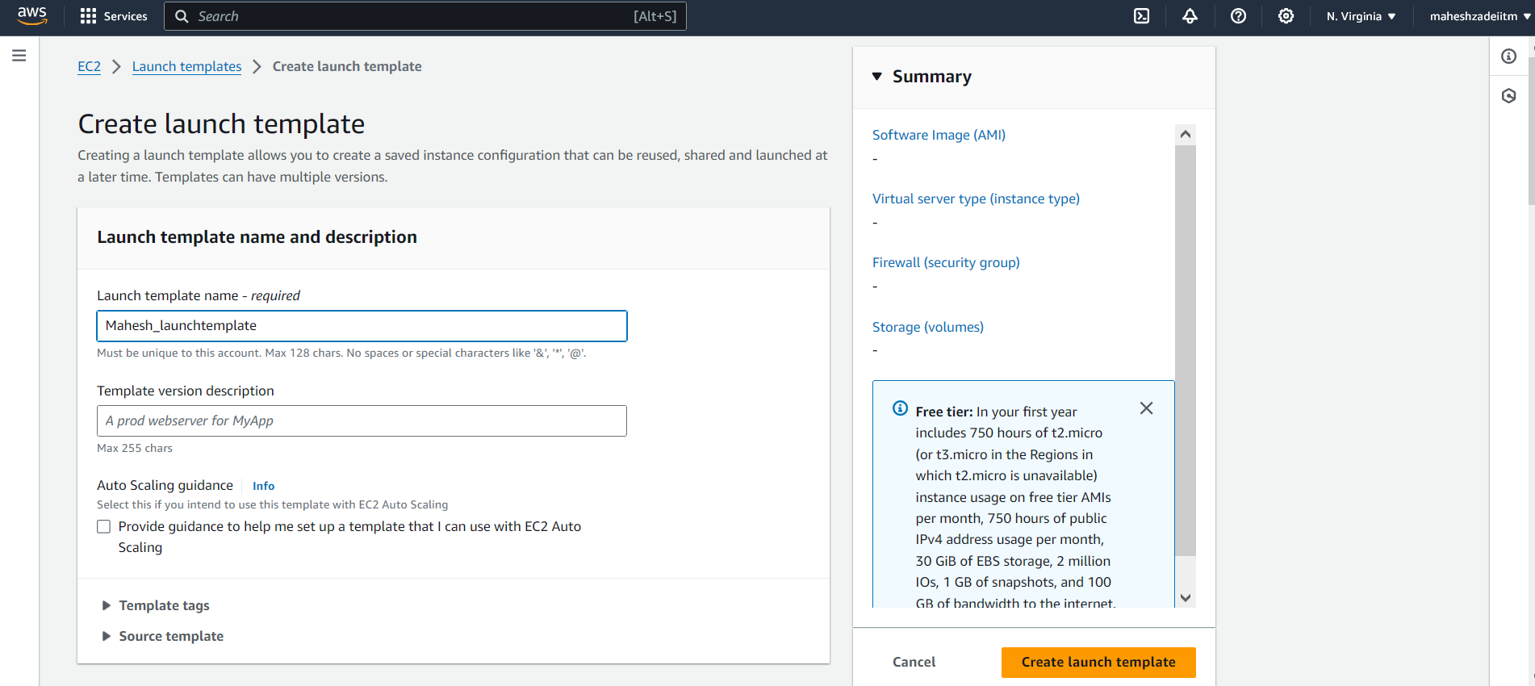

Go to My AMI option and select owned by me image automatically selected

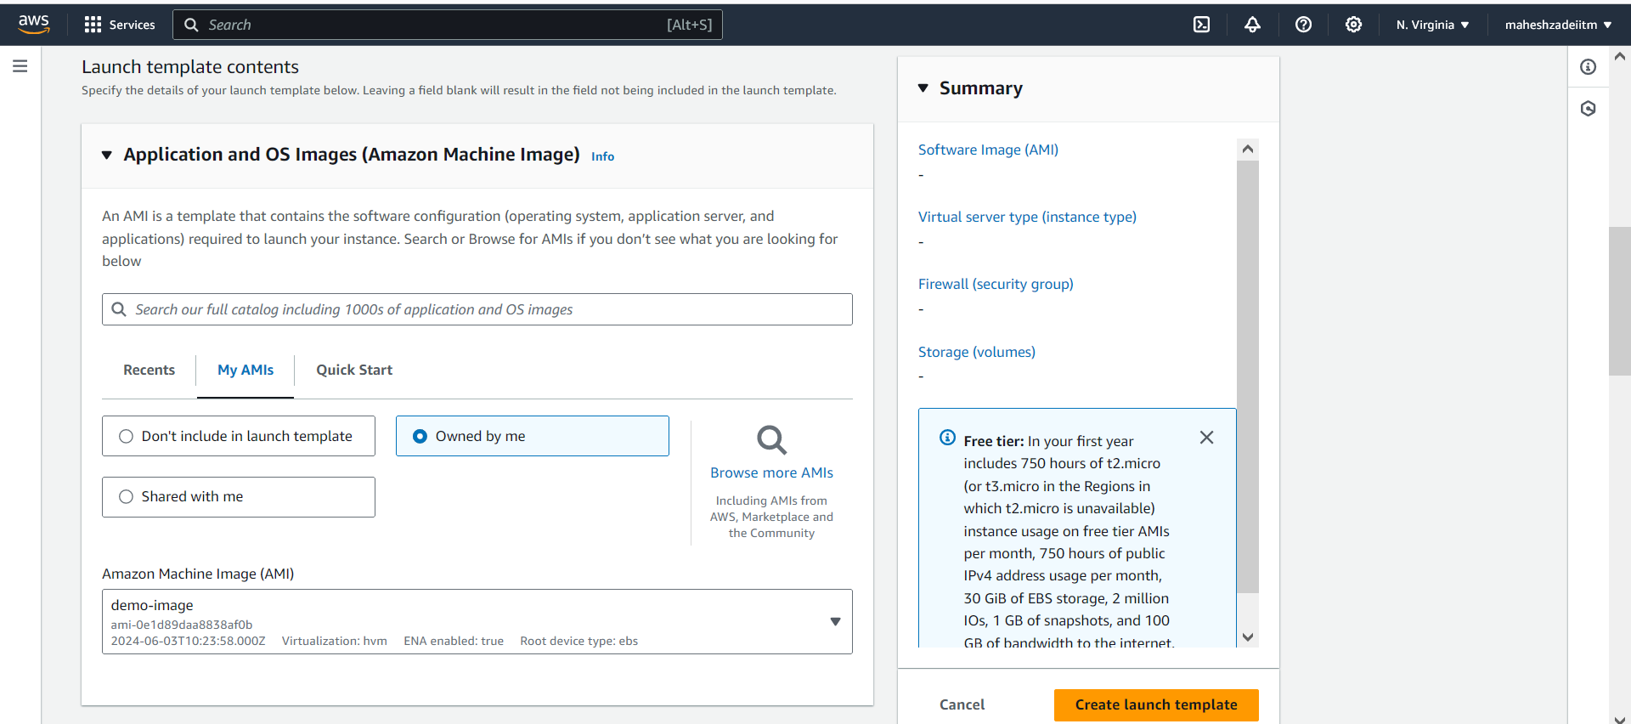

Instance Type selectt2.micro

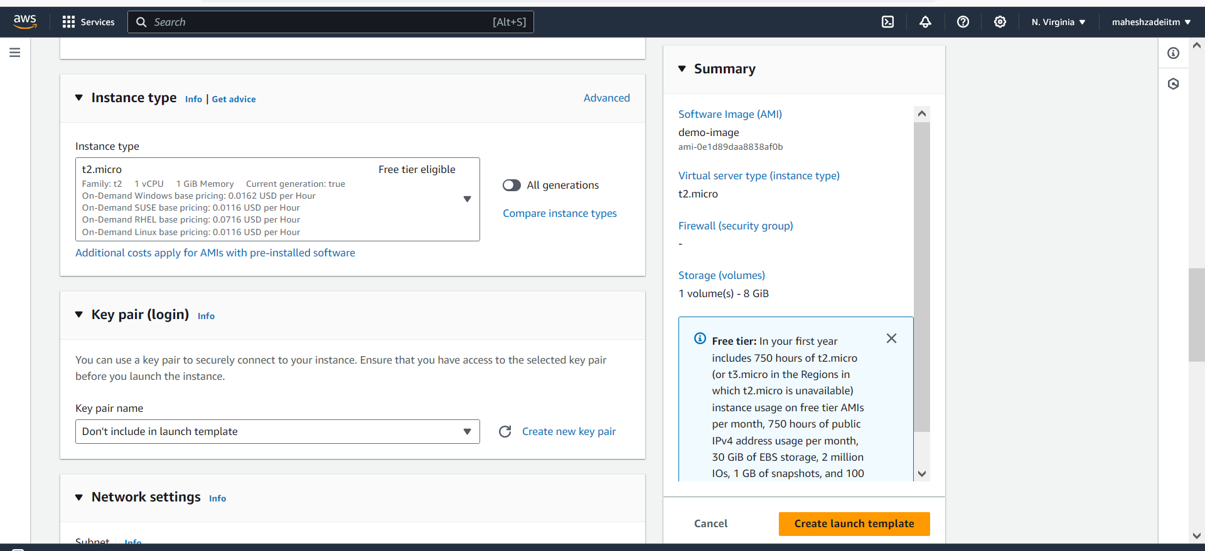

Specify keypair on N vergunia

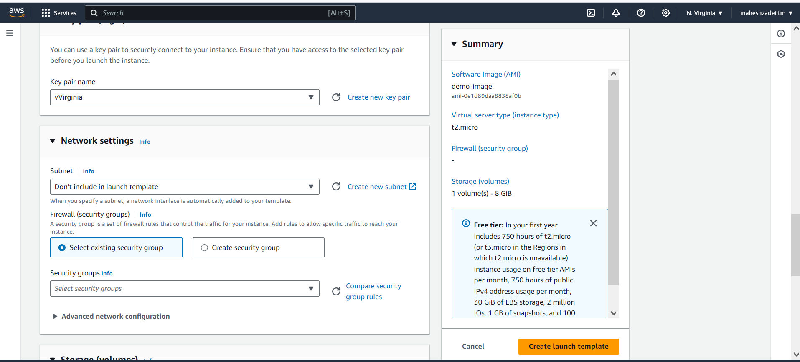

Select SG which we created

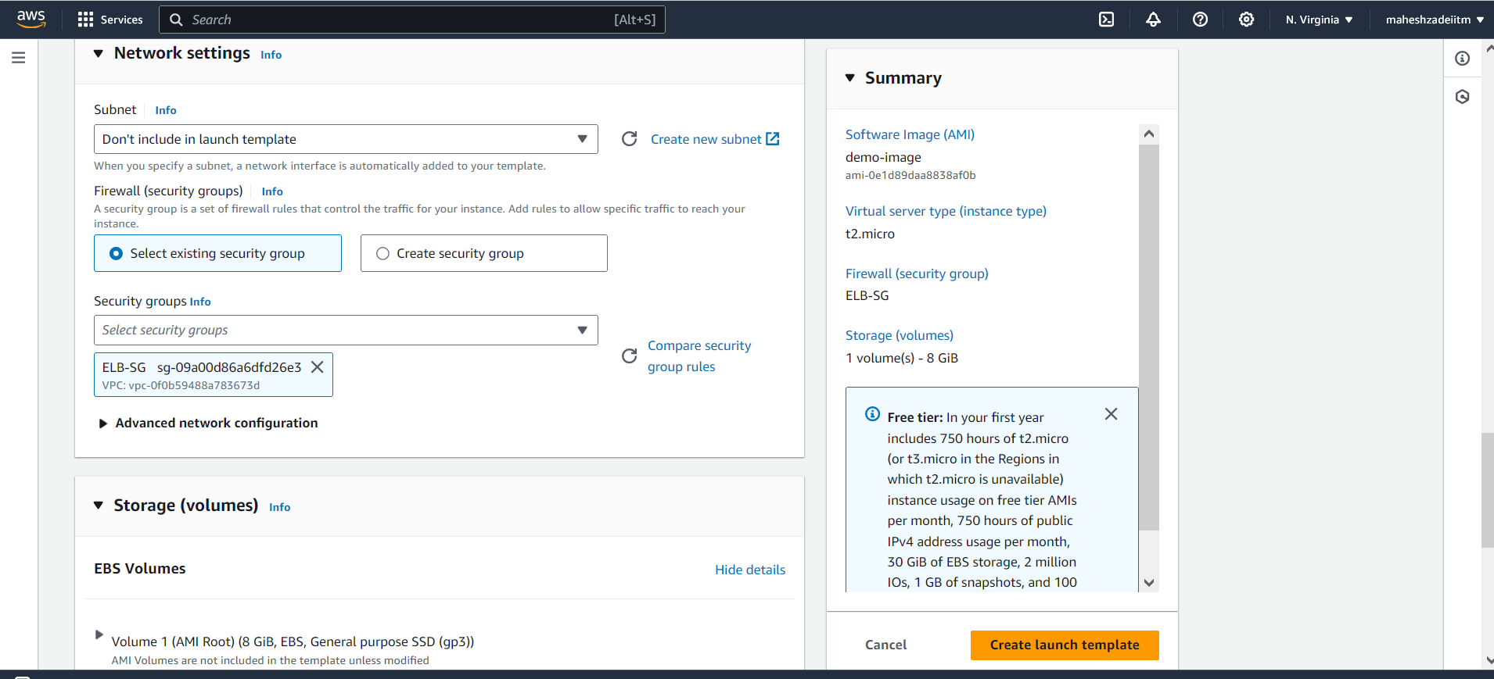

Click on launch Template

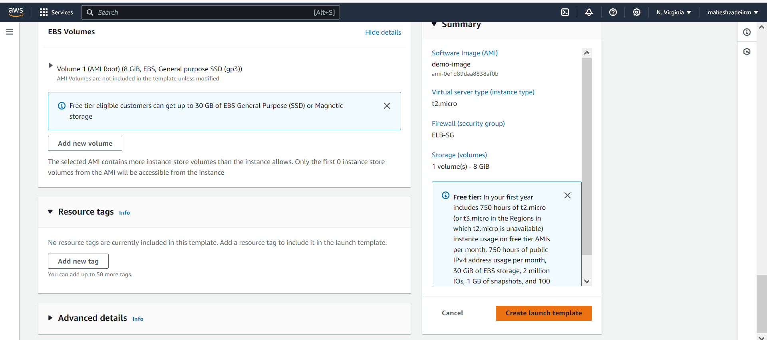

Template Launched

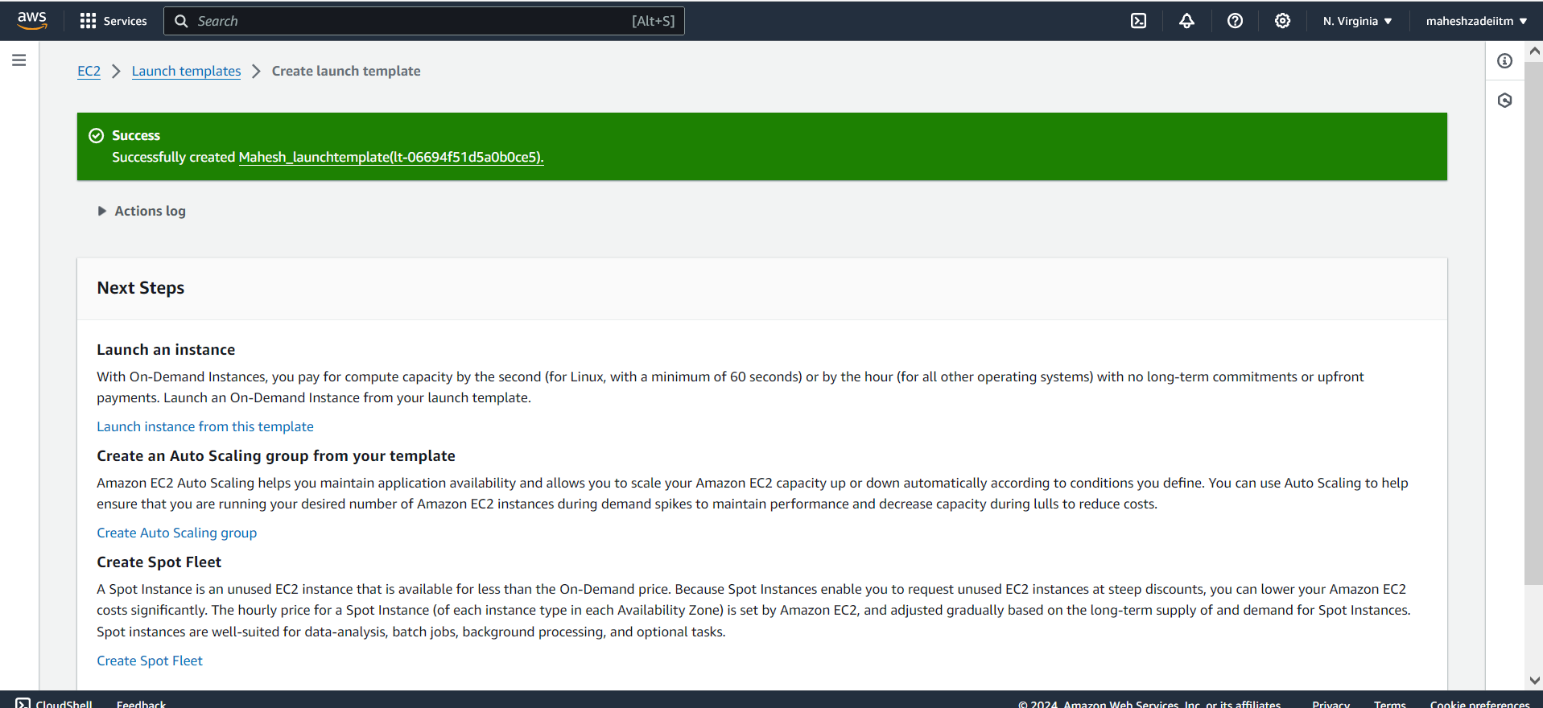

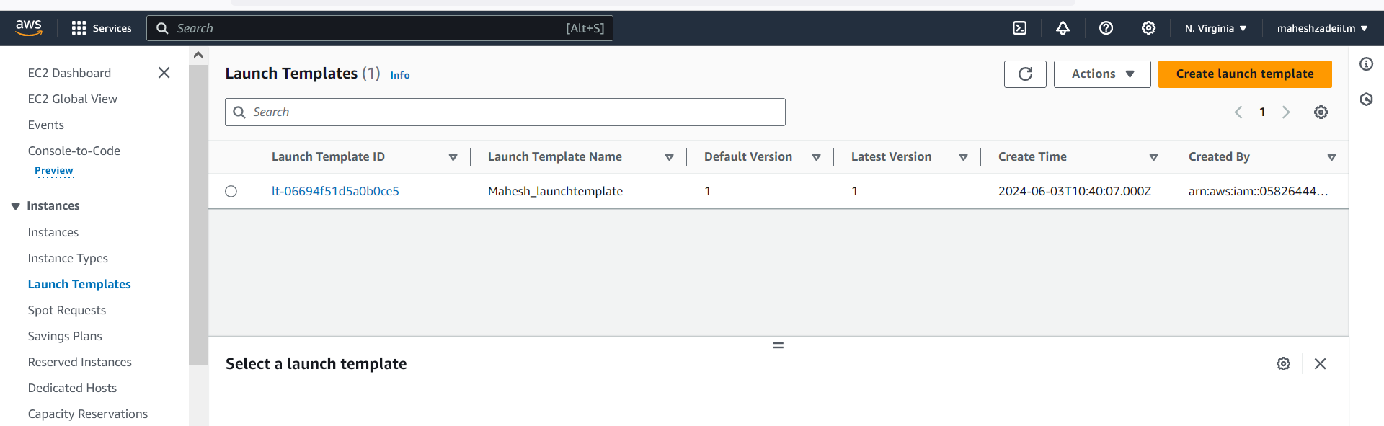

Now Go to AWS Console to create the Auto scaling Group

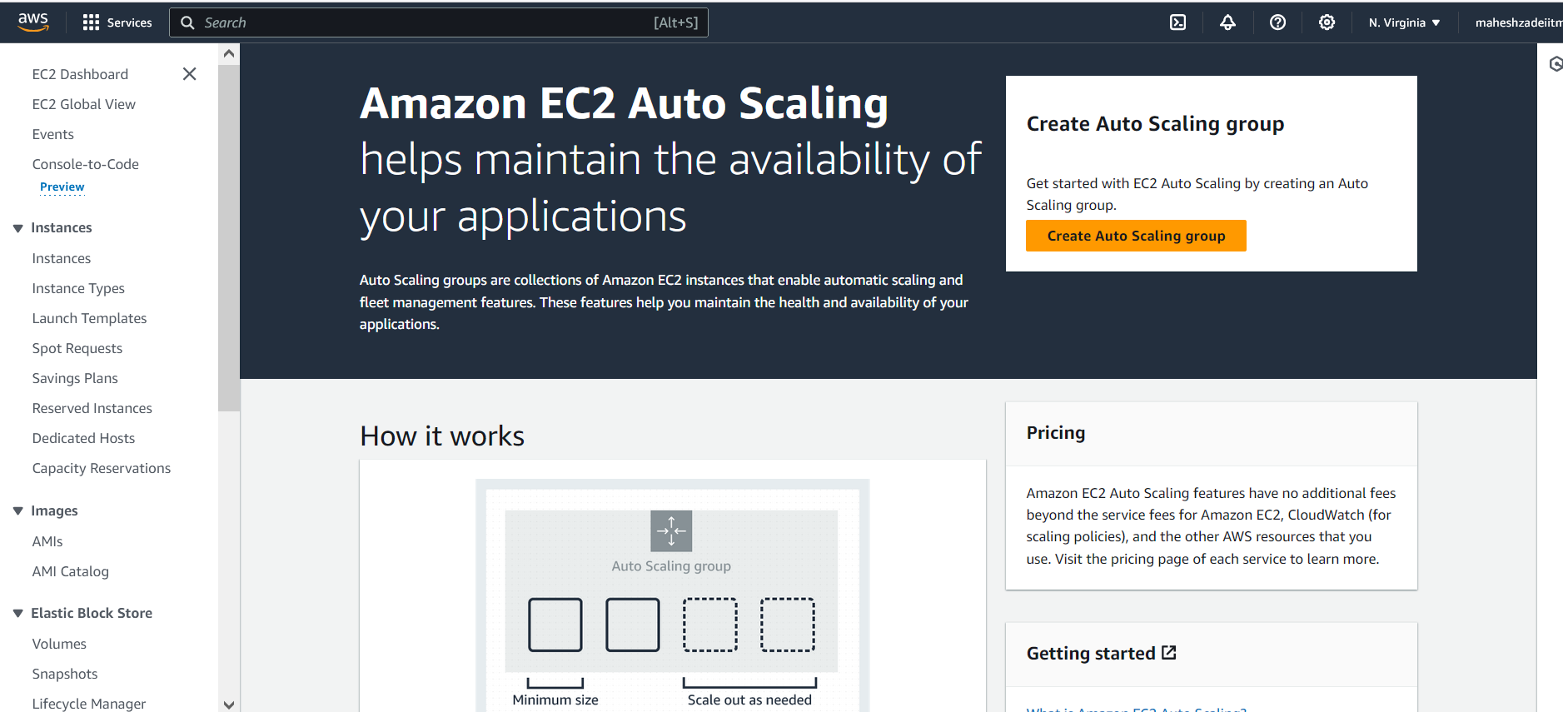

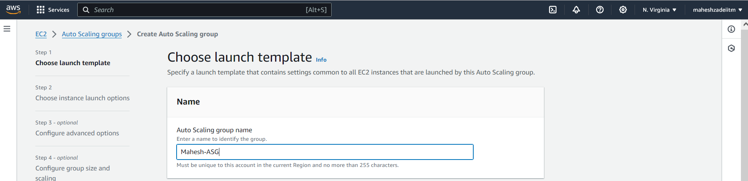

Select launch Template

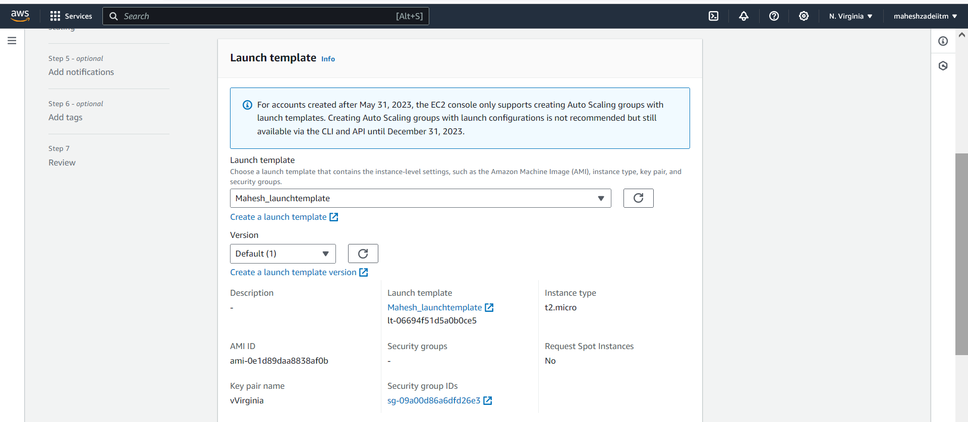

Next

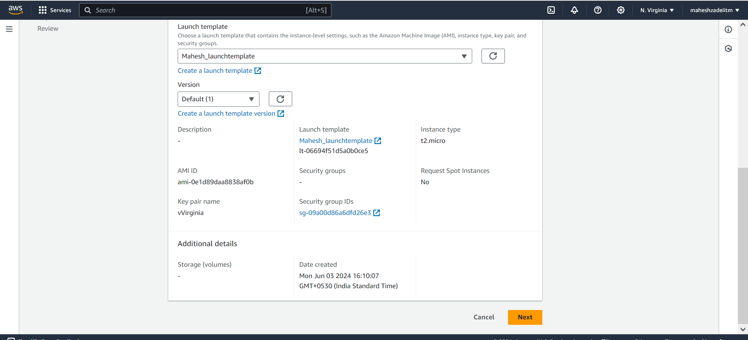

Instance type t2 micro 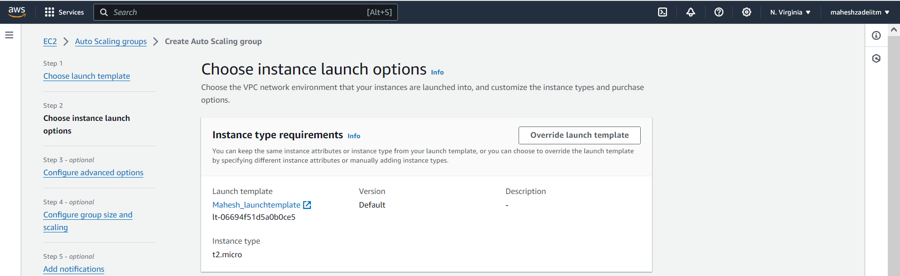

Select default VPC and all AZ and click on next

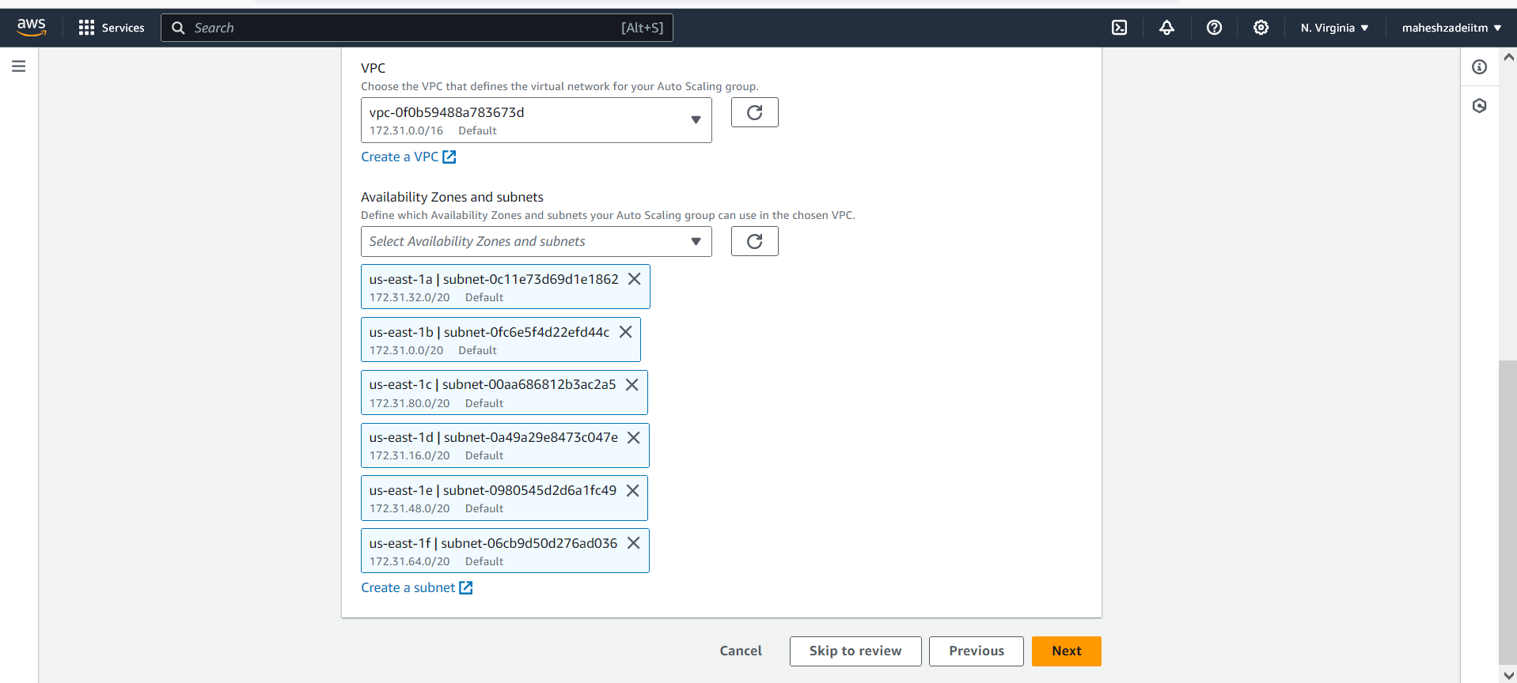

Leave all the setting as it is

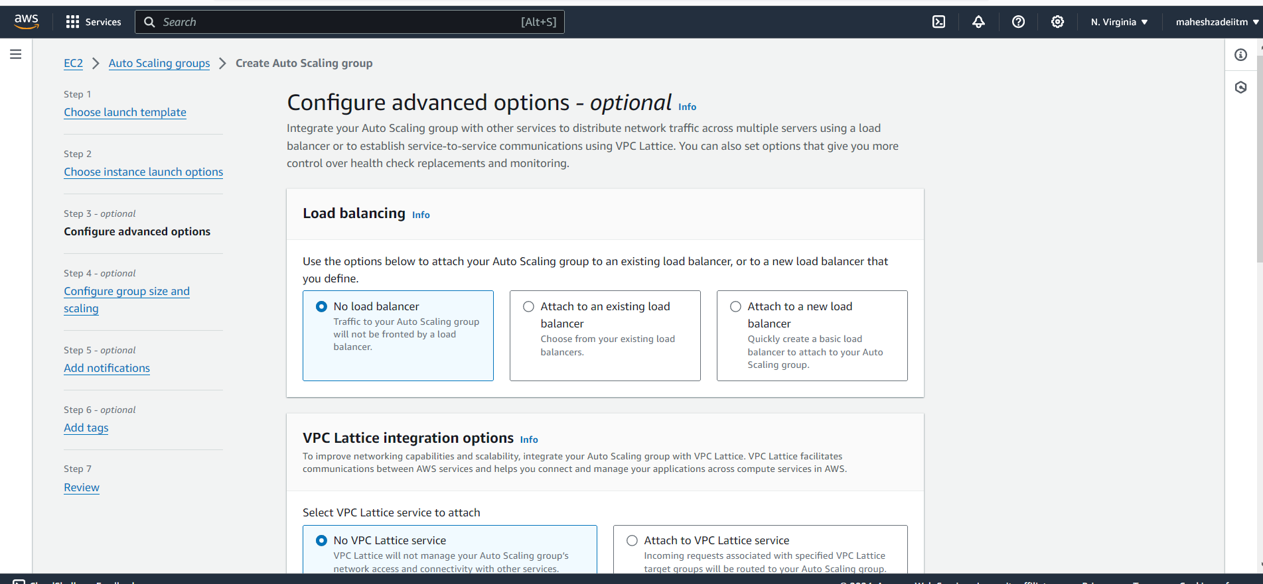

Click on next

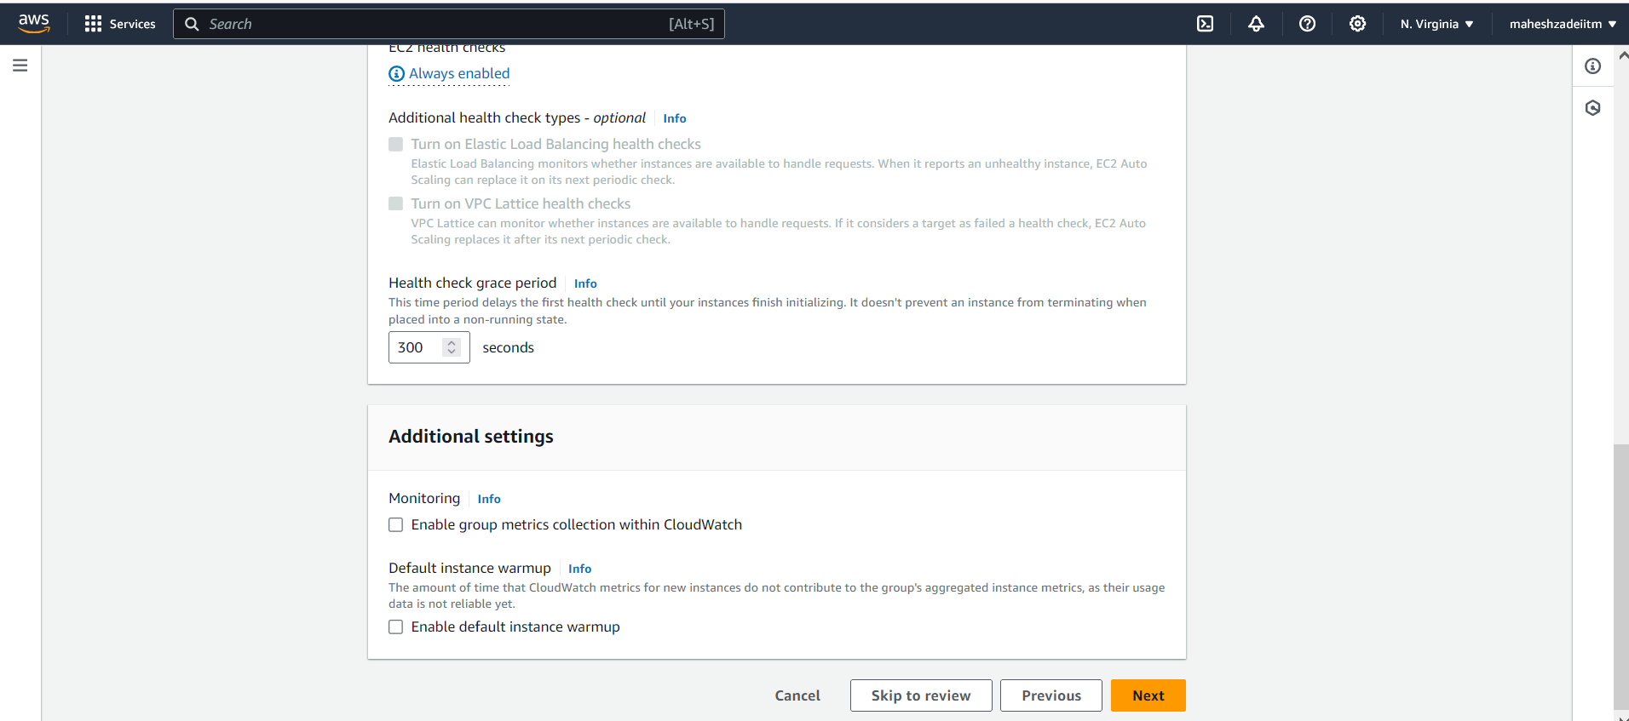

Scaling need to select min 1 and Max 3

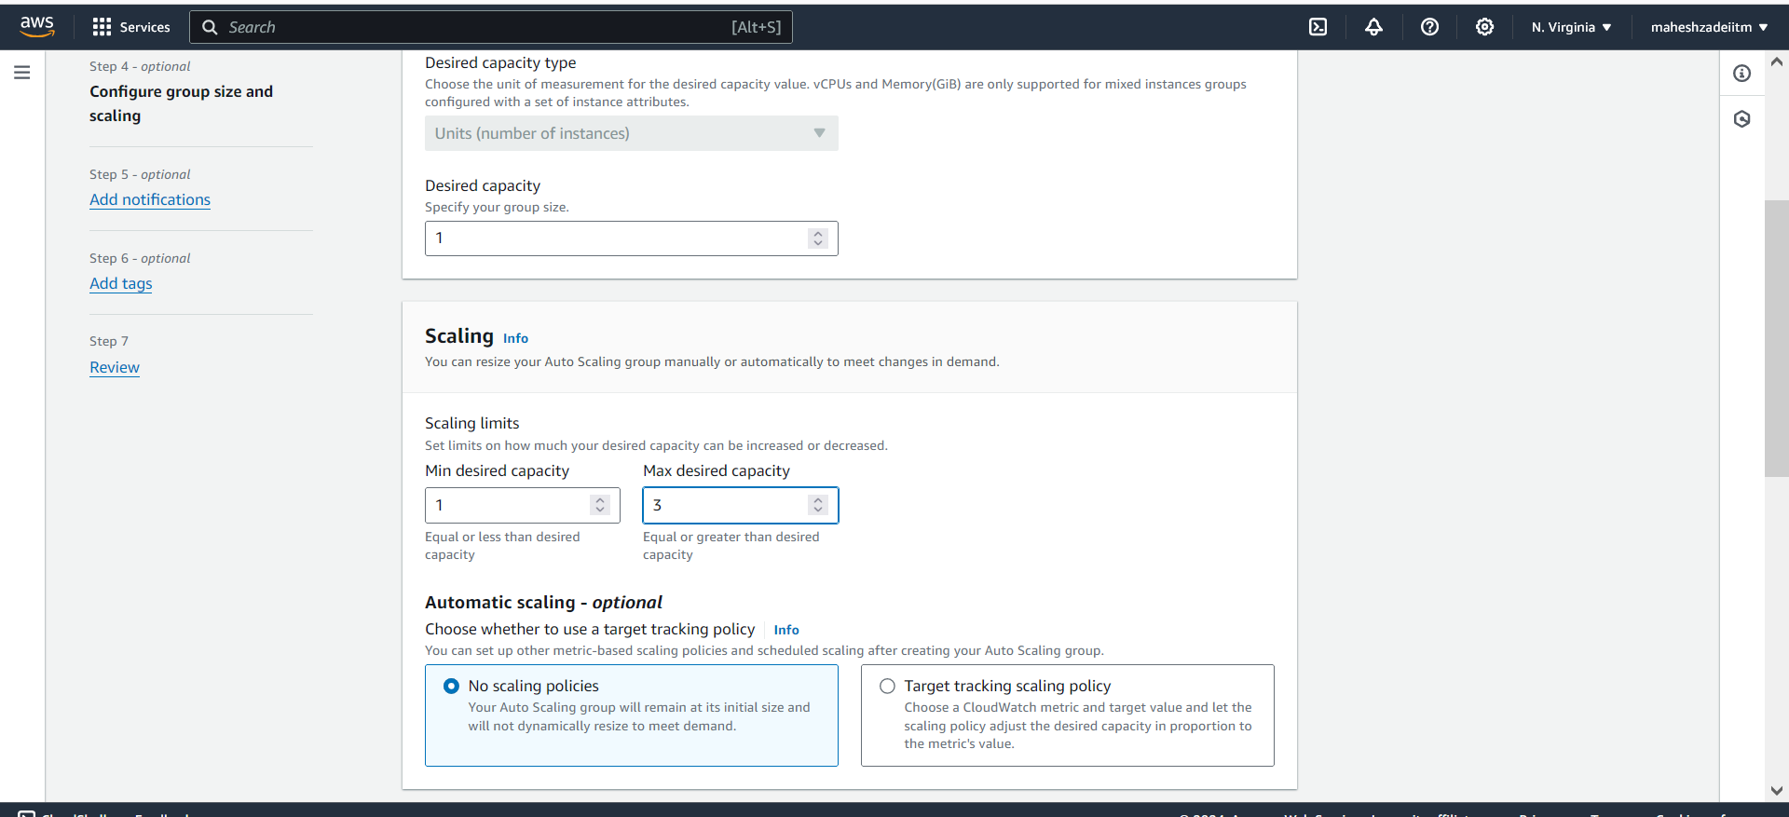

Next

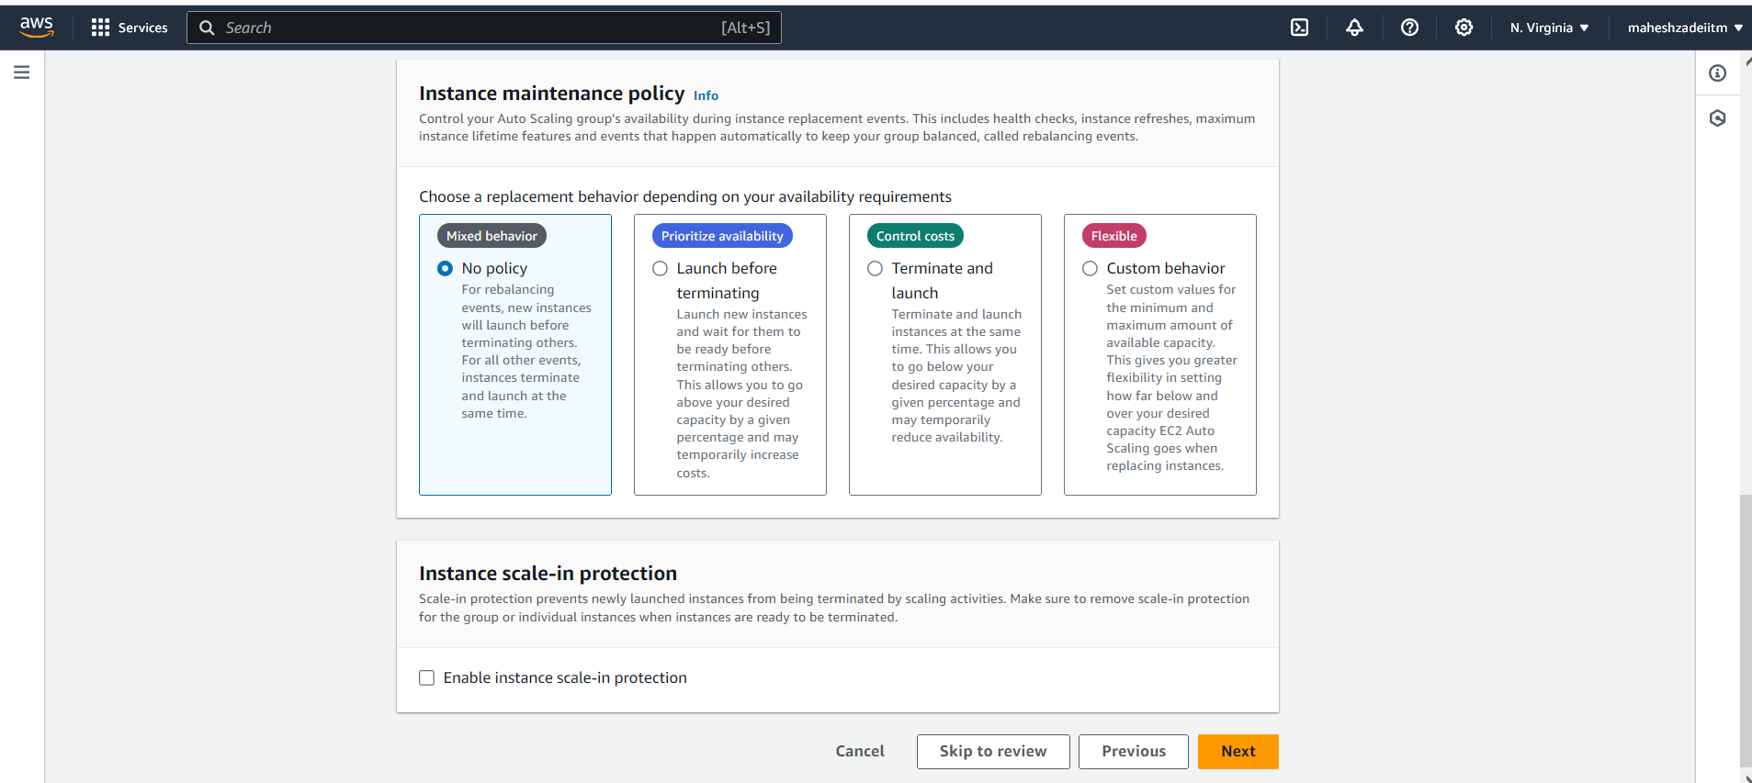

Next

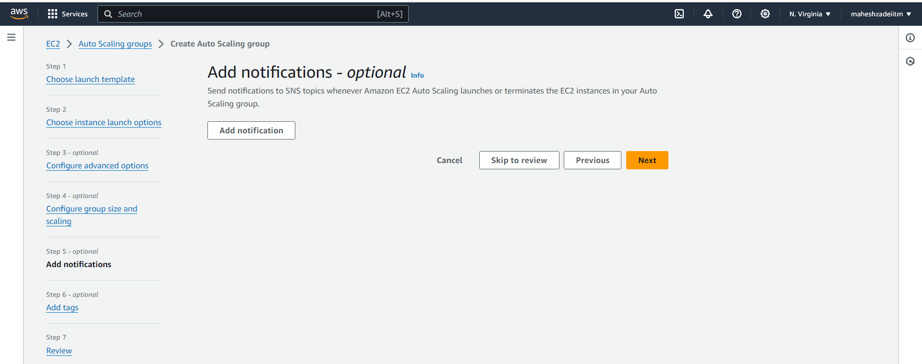

Next

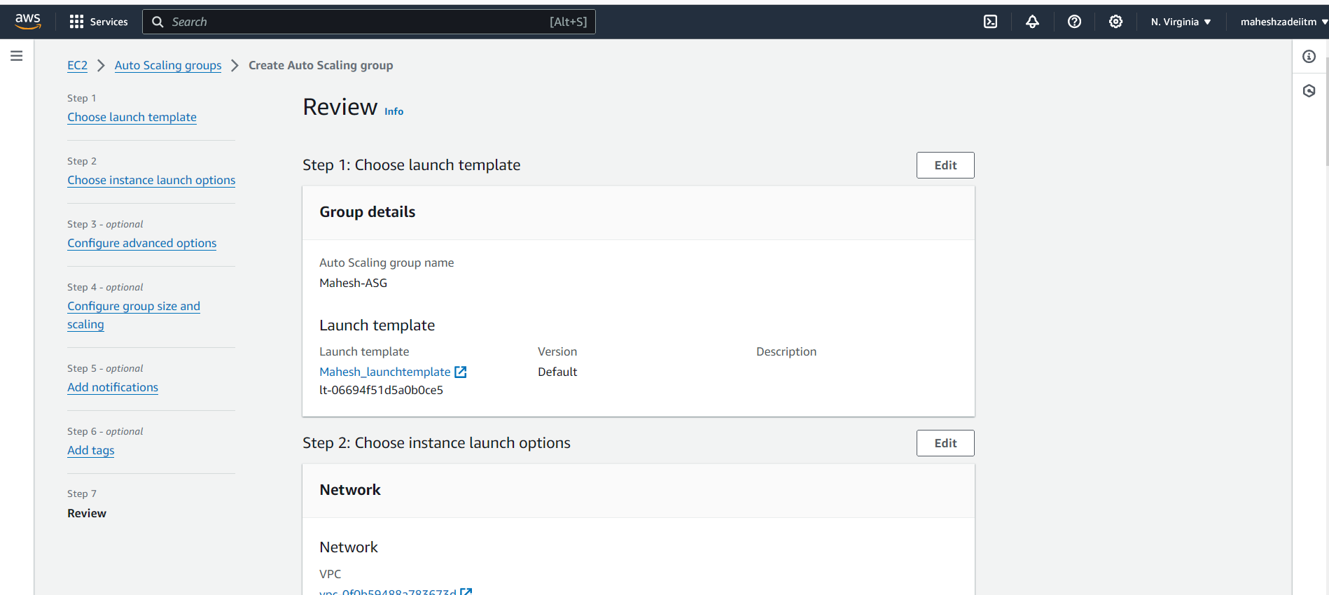

Click on create Auto Scaling Group

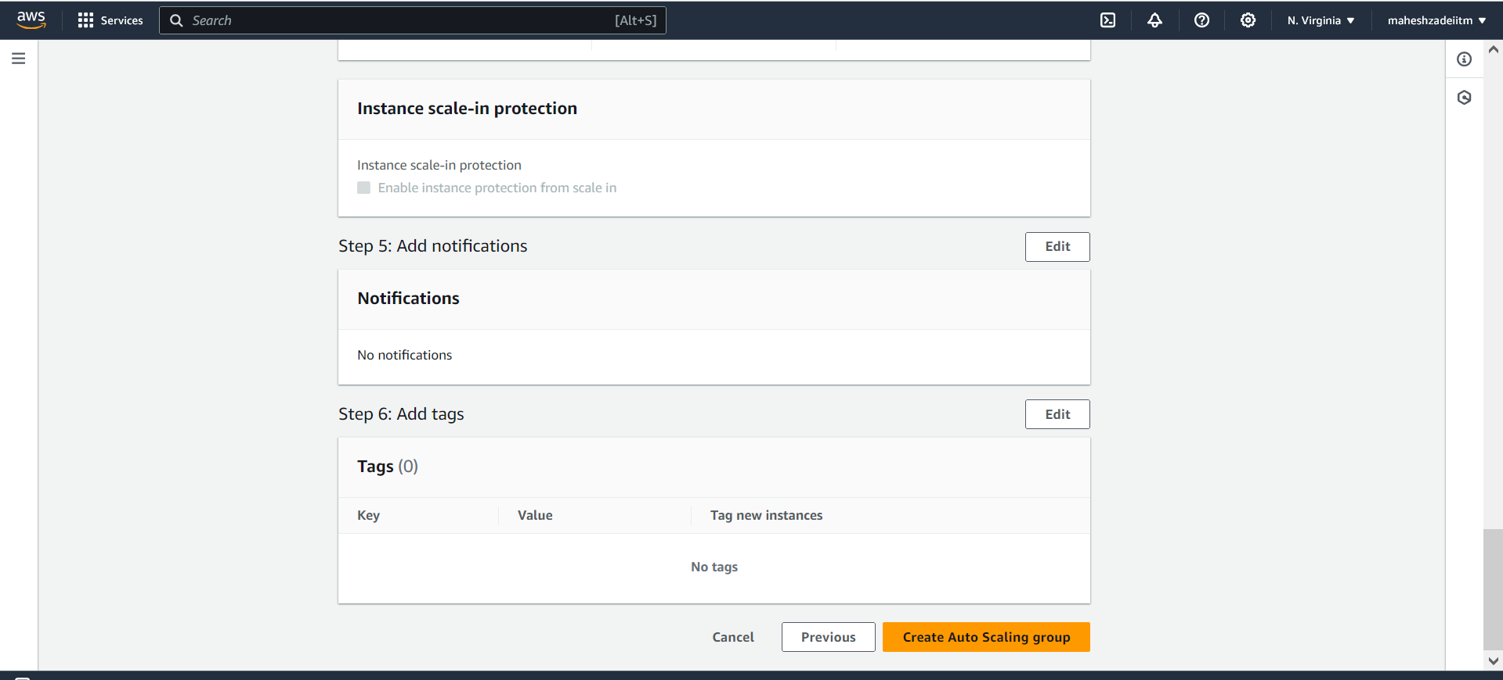

Crated Auto Scaling group

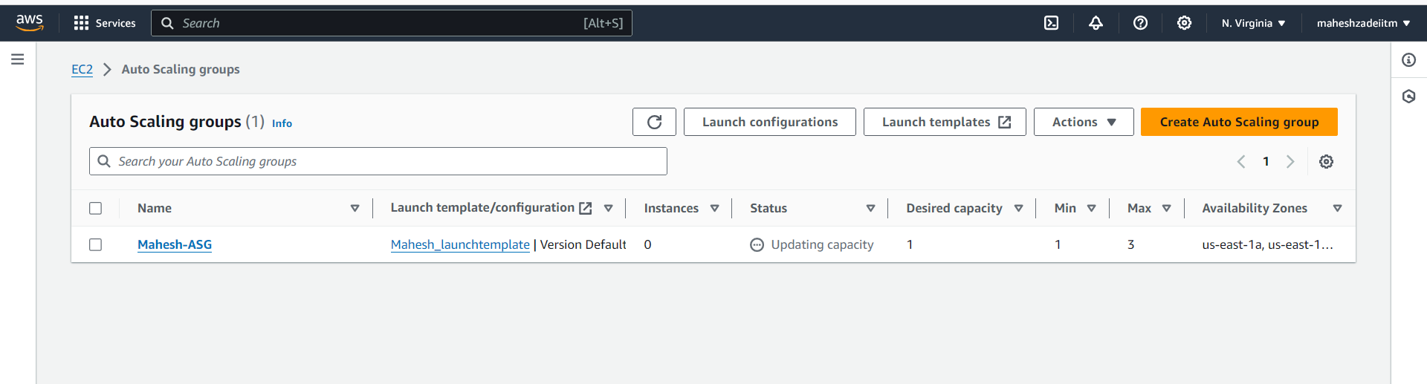

EC2 is created in EC2 Dashboard

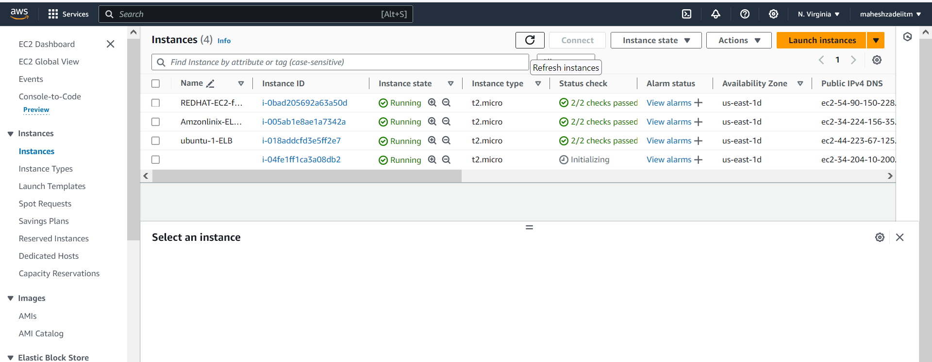

Still initializing

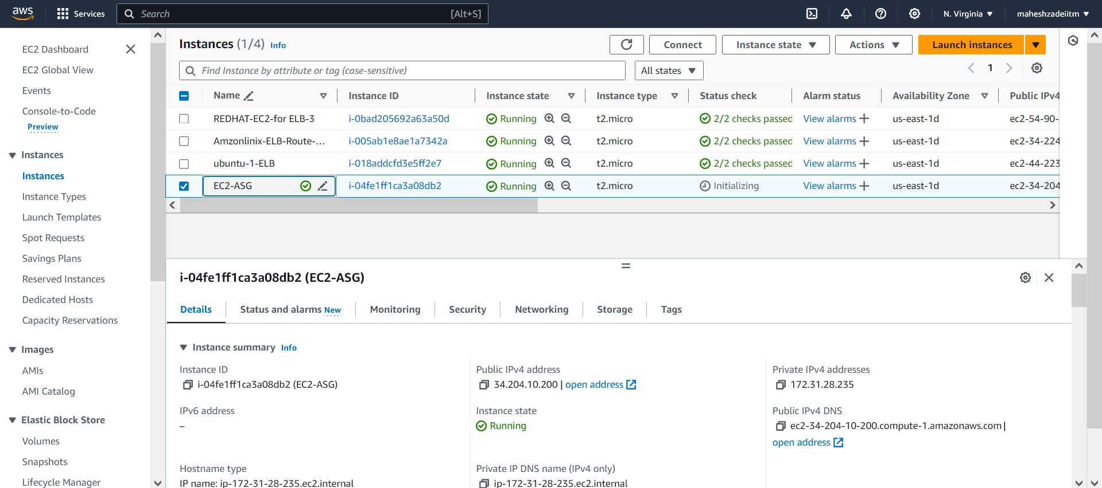

EC2-ASG instacne is Available now by Auto sclaing group

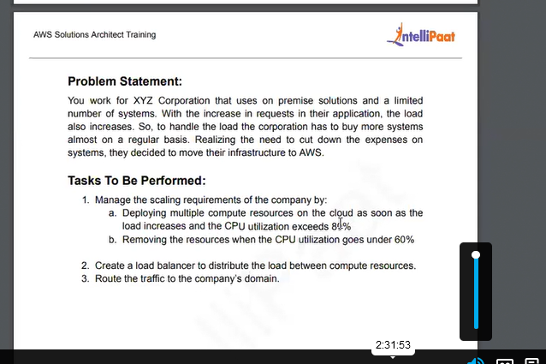

Now Go to Auto scaling group for CPU Utilization in Automatic scaling option

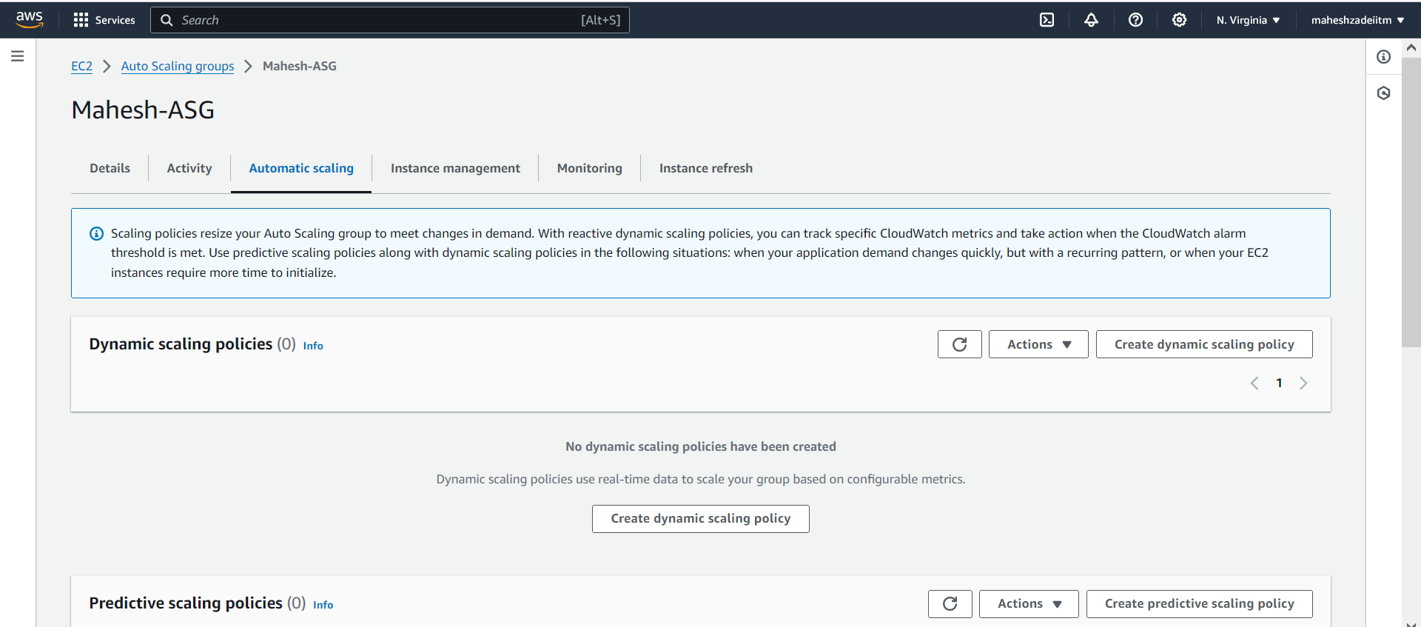

Dynamic scaling policies

Amazon EC2 Auto Scaling can add more instances (referred to as scaling out) to deal with high demand at peak times, and run fewer instances (referred to as scaling in) to reduce costs during periods of low utilization.

When you create a target tracking scaling policy, Amazon EC2 Auto Scaling automatically increases and decreases capacity in response to varying usage levels. For example, a target tracking scaling policy might have a target CPU value of 50 percent. Amazon EC2 Auto Scaling then launches and terminates EC2 instances as required to keep the aggregated CPU usage across all instances in your group at 50 percent.

With step scaling and simple scaling, you must create alarms in Amazon CloudWatch, and then define two policies, one for scaling out and the other for scaling in. Step scaling can make bigger or smaller size adjustments based on the metric value, while simple scaling always makes the same size adjustment.

Click on Create dynamic scaling policy

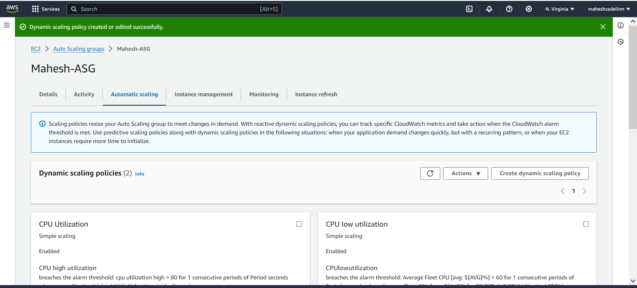

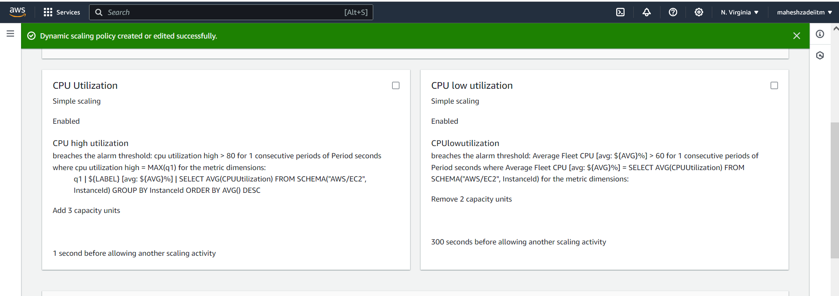

Now go to Monitoring and check

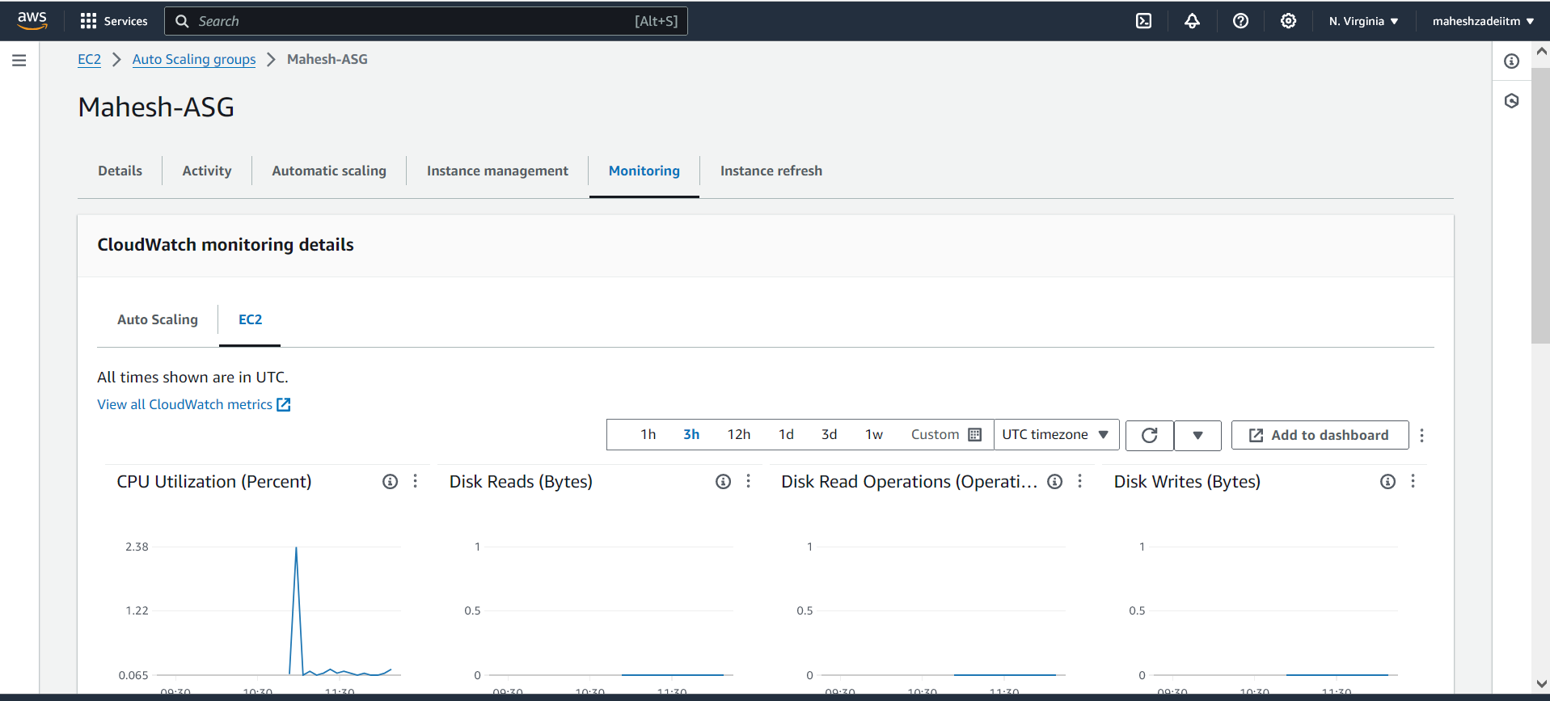

**Route 53 for Traffic Routing:**

Create a hosted zone in Amazon Route 53 with a record set pointing to the ALB's DNS name.

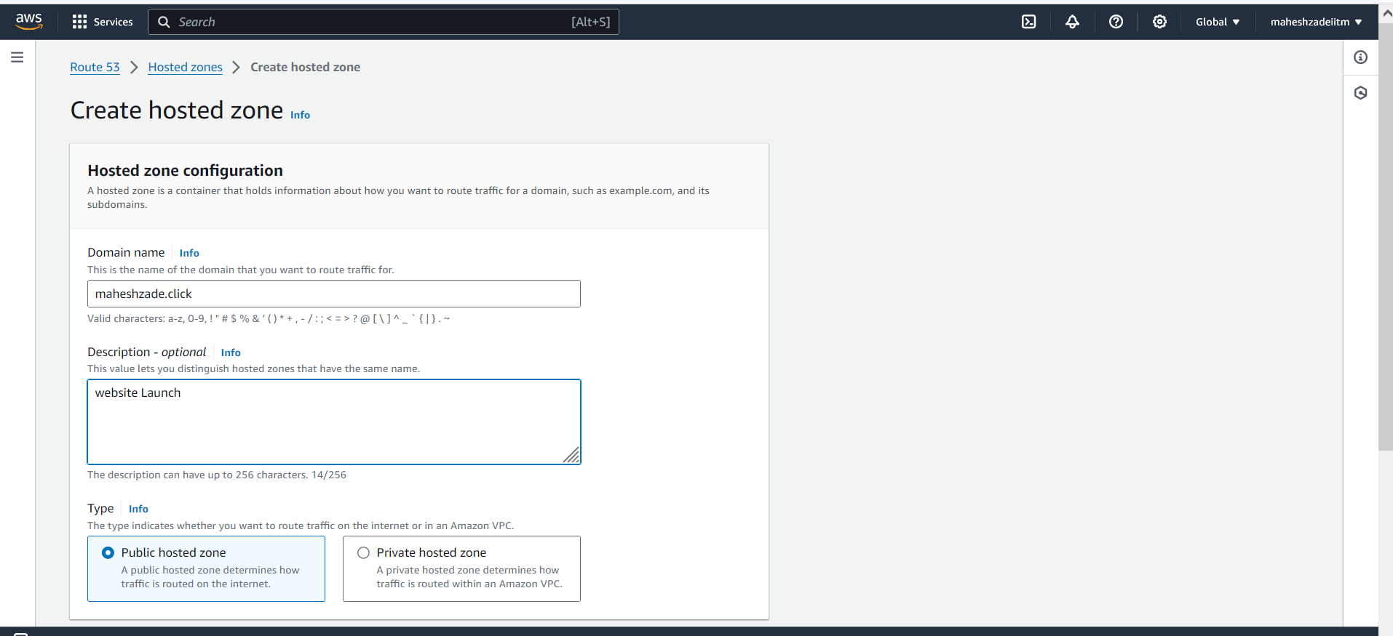

Create hosted zone

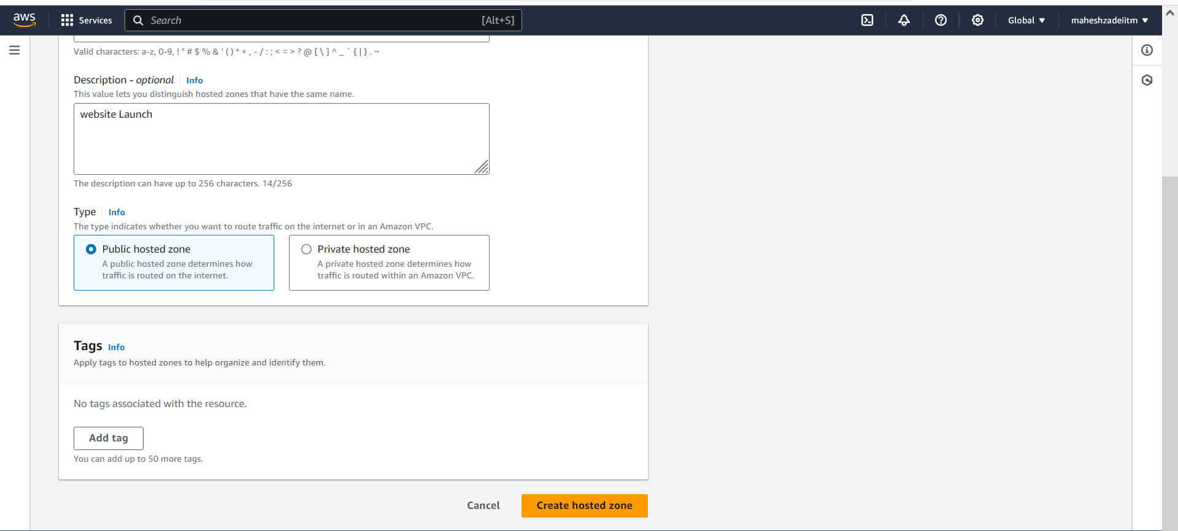

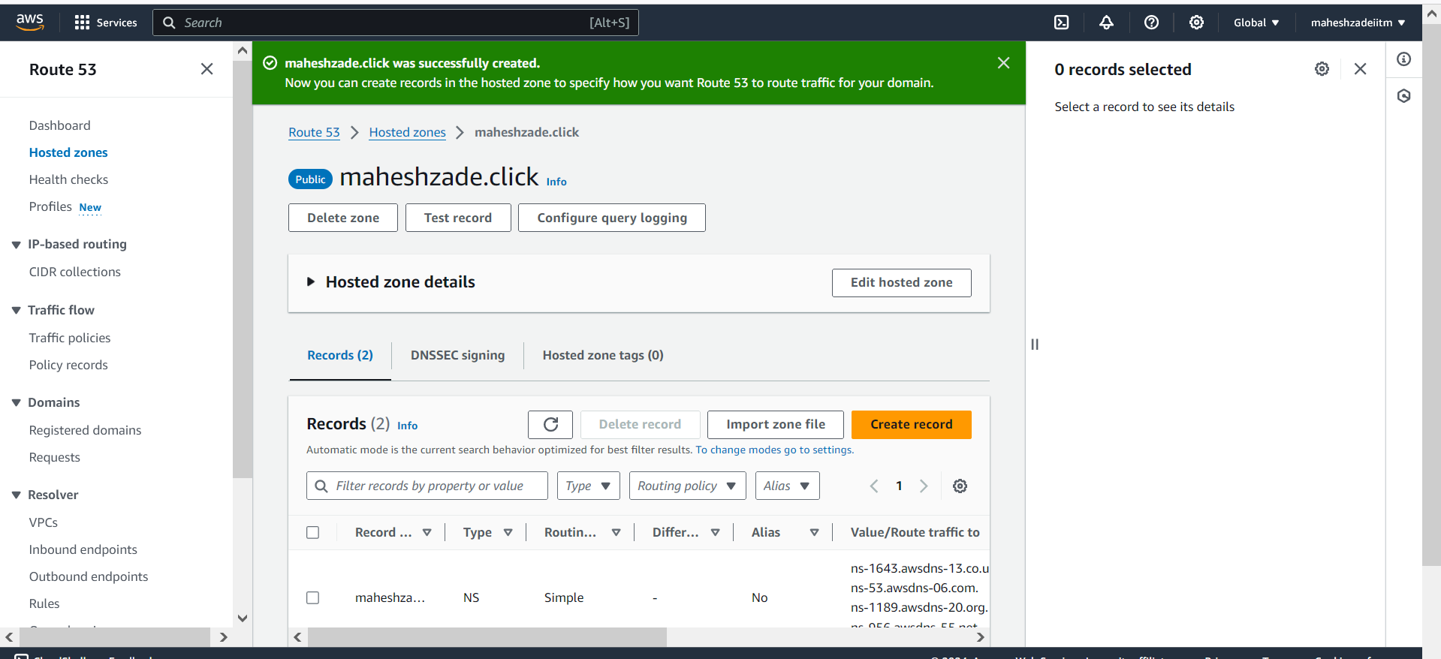

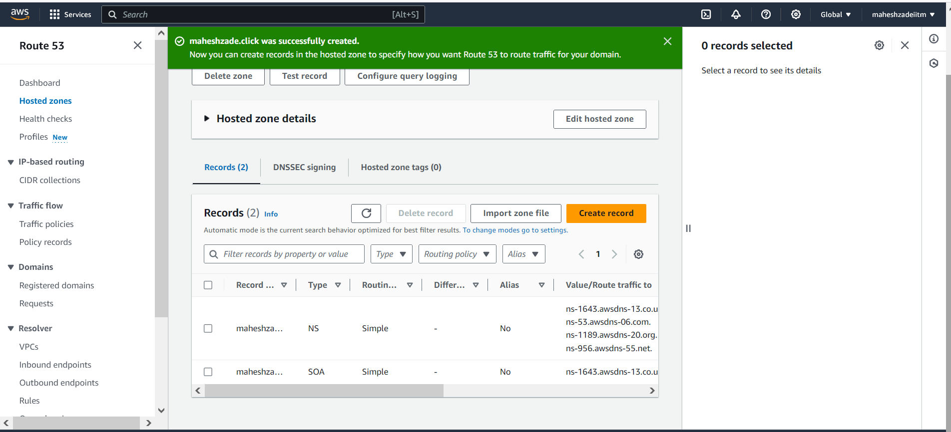

Configure your domain registrar to point the company's domain (e.g., xyzcorp.com) to the Route 53 hosted zone.( As Comapany domain is not available we are wring the steps ).

Configuring Your Domain Registrar to Point to Route 53

Here's how to configure your domain registrar to point XYZ Corporation's domain (xyzcorp.com) to the Route 53 hosted zone:

1. Access Your Domain Registrar Account:

Login to the control panel of your domain registrar (e.g., GoDaddy, Google Domains, Namecheap).

2. Locate Domain Management:

Navigate to the section where you manage your domain name (often labeled "Domains," "DNS Management," or similar).

3. Find DNS Records:

Look for a section related to managing DNS records for your domain. This might be called "DNS Management," "Advanced Settings," or "Name Servers."

4. Update Nameserver (NS) Records:

we need to update the nameserver (NS) records for your domain. These records point to the servers that manage your domain's DNS information.

Replace the existing NS records with the nameservers provided by Route 53 when you created the hosted zone.

Typically, you'll find four Route 53 nameservers starting with "ns-".

5. Save Changes:

Once you've replaced the NS records with Route 53 nameservers, save your changes.

Propagation Time:

It can take up to 24 hours for the changes to propagate throughout the internet. During this time, your domain might still point to the old DNS servers.

Additional Tips:

Consult your domain registrar's documentation for specific instructions on updating NS records.

Consider taking a screenshot of your current DNS records before making changes, in case you need to revert.

By following these steps, you'll successfully configure XYZ Corporation's domain (xyzcorp.com) to point to the Route 53 hosted zone, allowing you to manage its DNS records and route traffic to your AWS application.

Benefits:

Automatic Scaling: Automatically adjusts resources based on demand, eliminating the need for manual provisioning.

Cost Optimization: Utilizes resources efficiently by scaling up during peak loads and down during low periods.

High Availability: The ALB distributes traffic across healthy instances, ensuring application uptime if one instance fails.

Scalability: Easily scales to accommodate future growth in traffic without infrastructure limitations.

Additional Considerations:

Monitoring: Use CloudWatch to monitor key metrics like CPU utilization, network traffic, and application health.

Security: Implement security groups to restrict inbound and outbound traffic for your EC2 instances.

Notifications: Set up notifications for scaling events and any potential issues.

This solution provides XYZ Corporation with an automated and cost-effective way to manage scaling requirements, ensure high availability, and route traffic to their application on AWS.

Assigmnet for ELBS and Route 53 Competed Succesfully .

Thanks

Mahesh Zade

Pls check and update

Thanks You